**Project Deliverable 2 – Documentation and Coding**

**Faculty Name:** Information Technology

**Module Code:** ITECA3-B12

**Module Name:** Web Development and e-Commerce

**Module Leader:** Ms Kariboba Mpwampu

**Copy Editor:** Mr Kevin Levy

**Submission Date:** 06/06/2022 – 10/06/2022

|  |  |
| --- | --- |
| **Student Name** | Dylan Petzer |
| **Student Number** | TRQVMVTF4 |
| **Project Title** | Bosch Northcliff Website |
| **Submission Date** | 13/06/2022 |

**Table of Contents**

2.1 Introduction 3

2.2 Prototyping 3

2.3 Designing 3

2.4 Coding 3

2.5 Conclusion 4

2.6 Sign-off 4

# Introduction

Bosch Northcliff is in need of a new website to try create an online presence and allow for customers to get a quote online. In the 2022 almost everything can be done online and Bosch would like to move in that direction. They requested a website with the ability to request a quote online. Bosch is an auto shop that provides services such as, car services, brake replacements and the list goes on. I would like for more people to visit their website whist having a user friendly experience. Every business in 2022 would benefit highly from an online presence, that’s why creating a space for Bosch online to attract new and youthful customers would be key to helping the business in the future.

In this document I will be showing the designs of the website, the diagrams used to model the website and the database structure of the website. The diagrams will show how the process will work and how we can expect the data to run through the website. This will help us understand what is needed and the flow of data that needs to be done within the website. I’ll be showing the prototypes built for Bosch and the way they look on different devices. It is important that all pages are responsive and neat to ensure ease of use for customer.

# Prototyping

Provide the screen shots of the two responsive prototypes asked in the project specification document. Each prototype must illustrate how all the pages of the website will be displayed on smart phones, tablets and desktops.

1. **Prototype 1.**

**Desktops:**

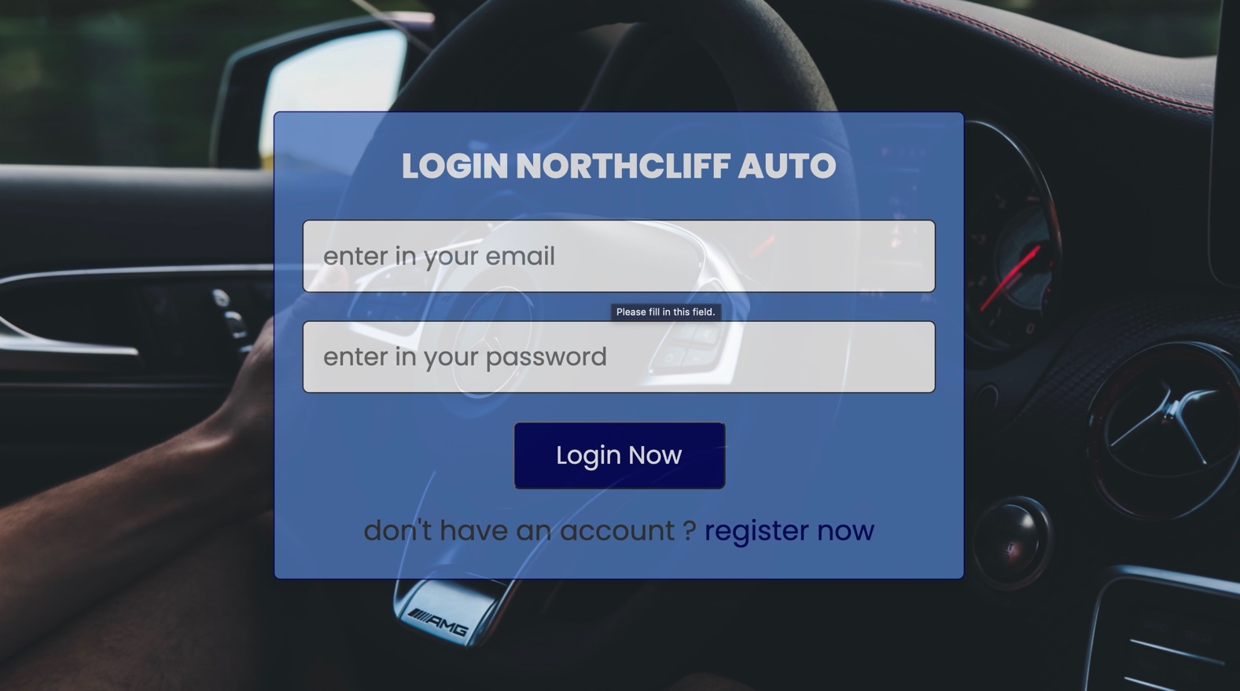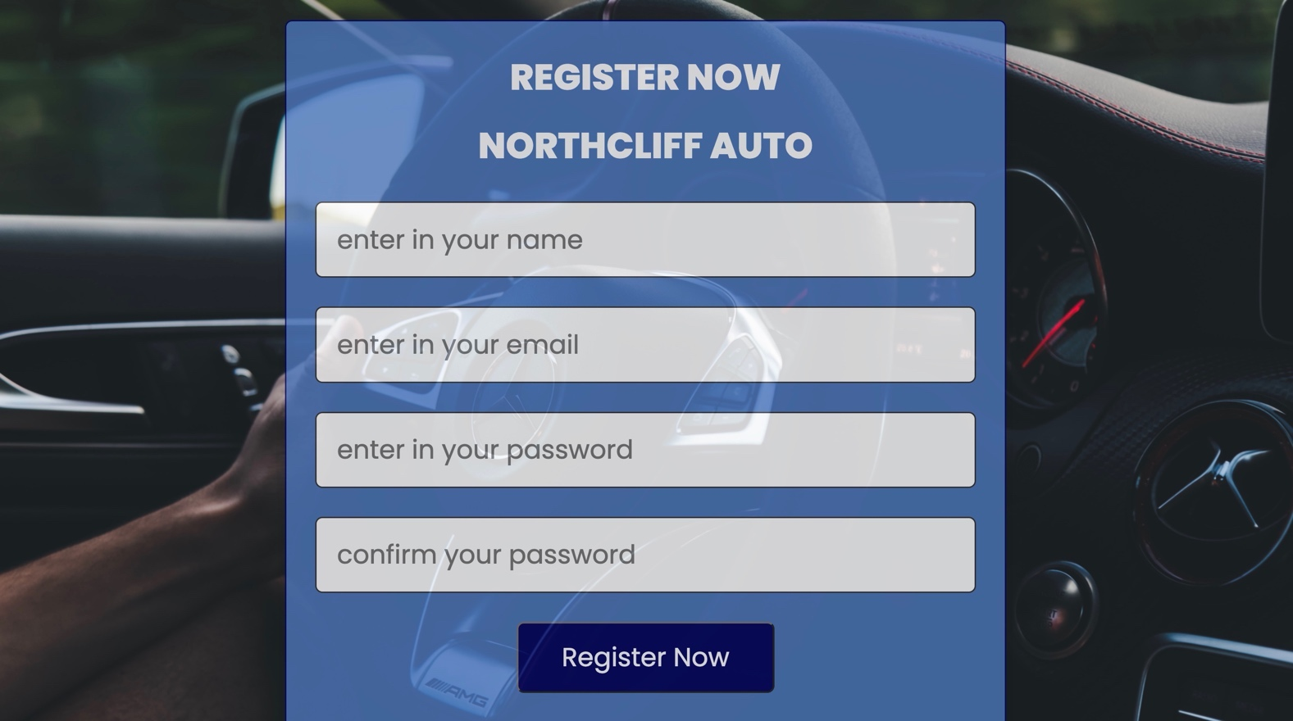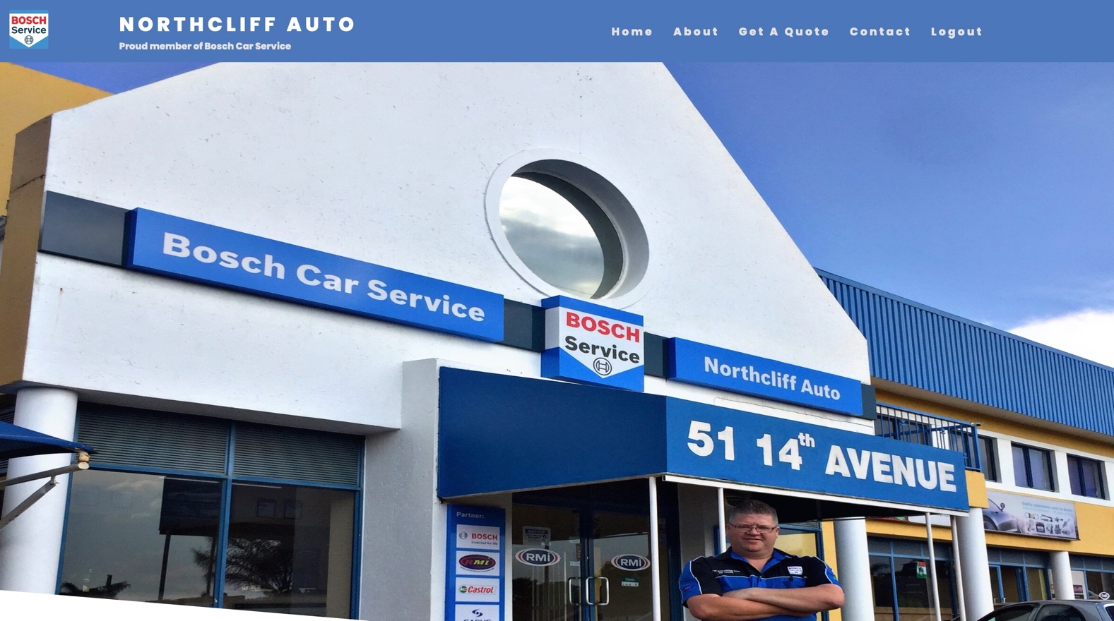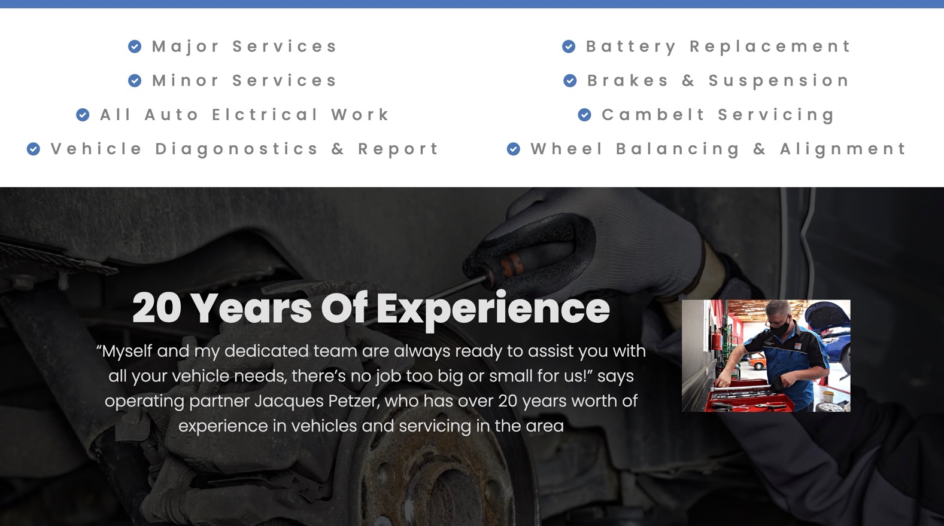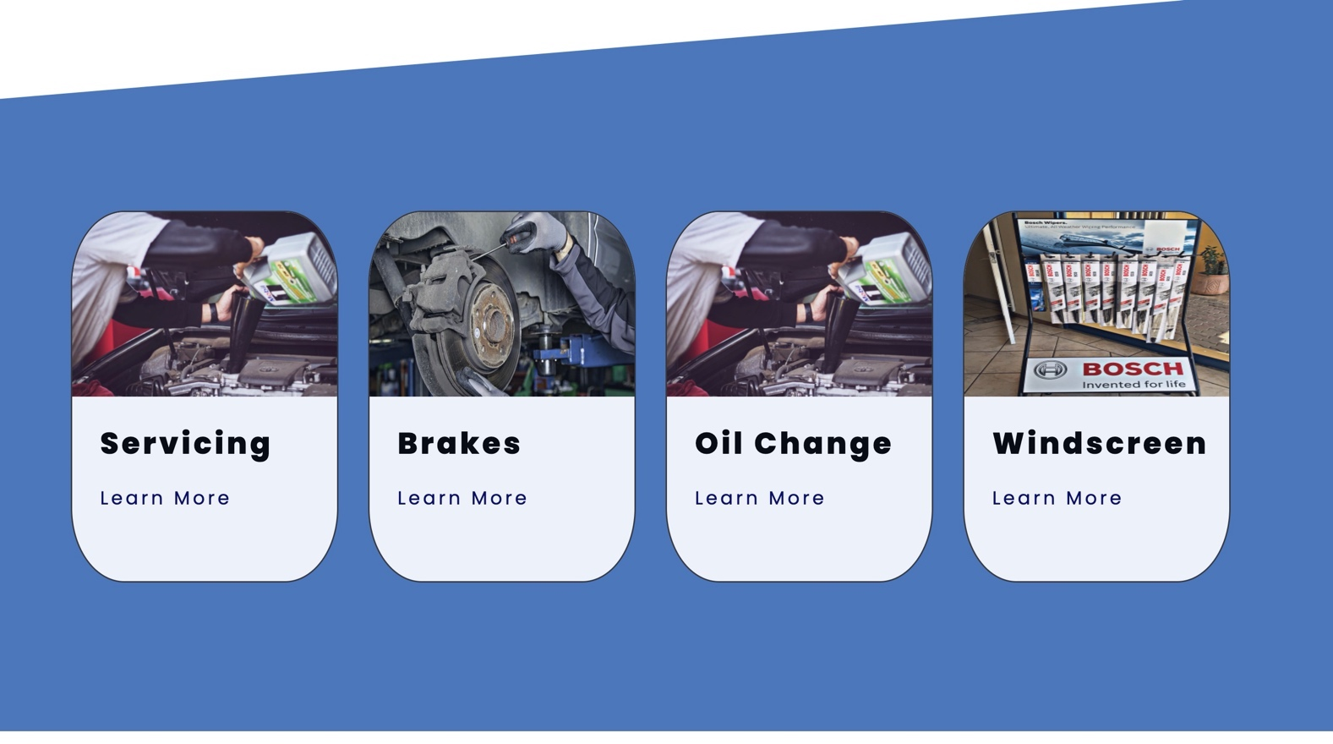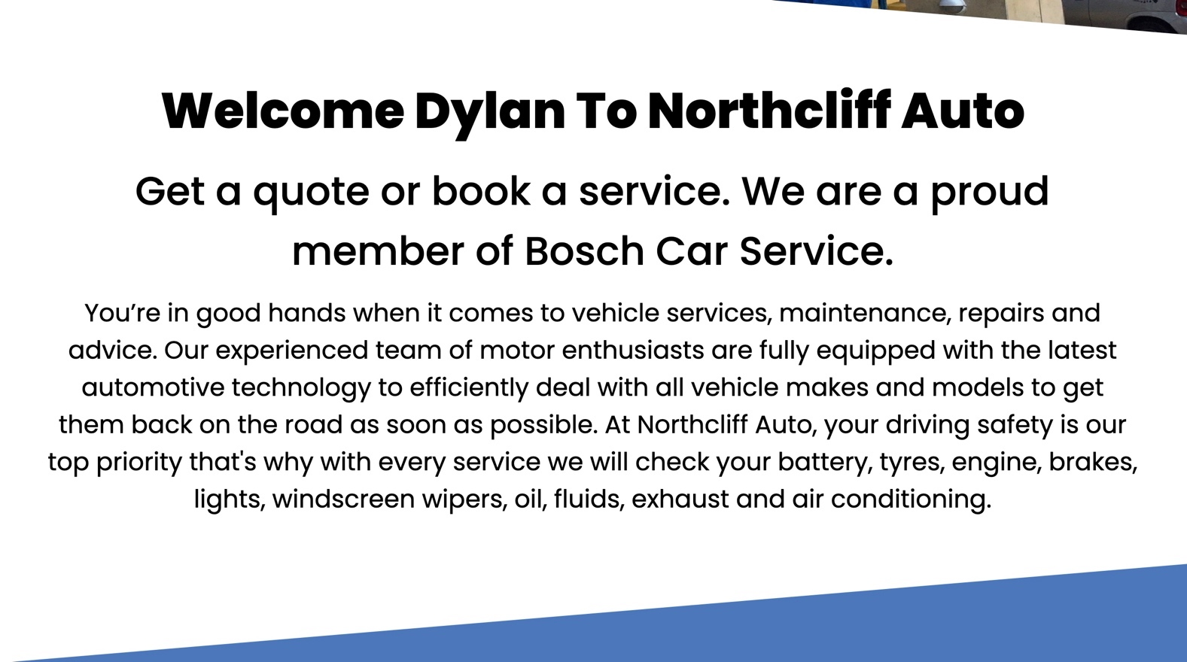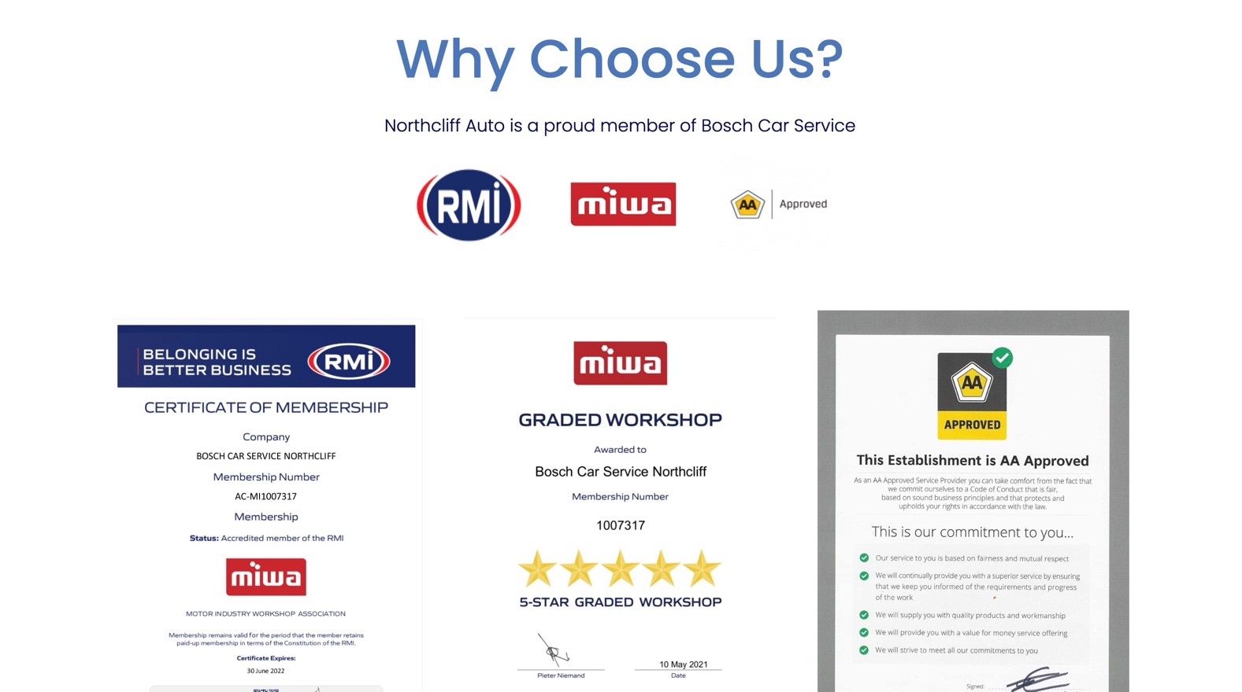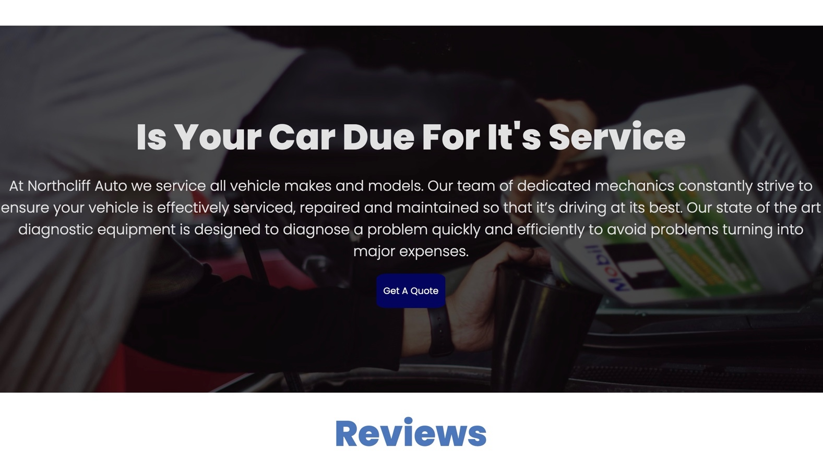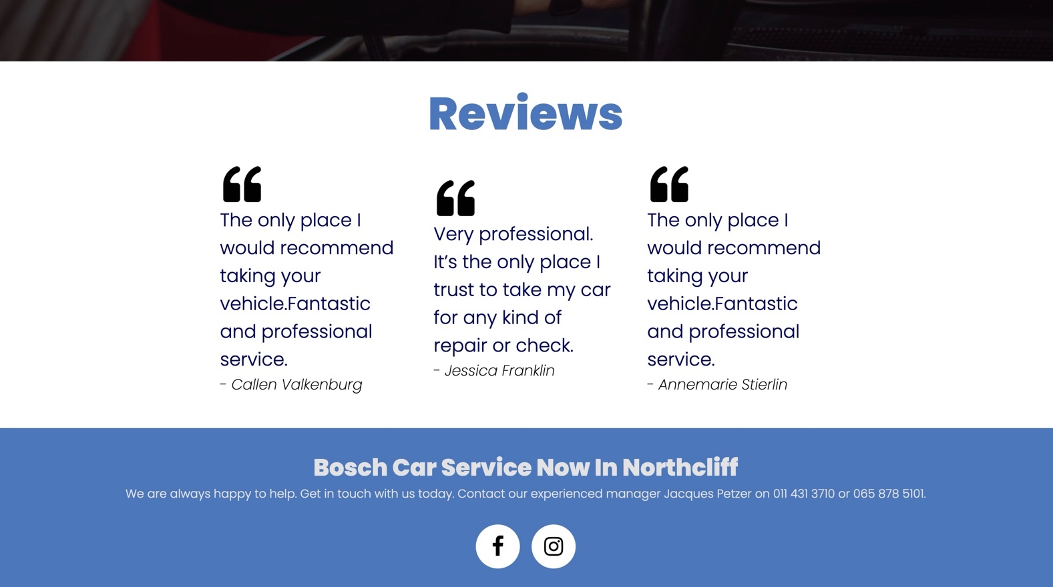

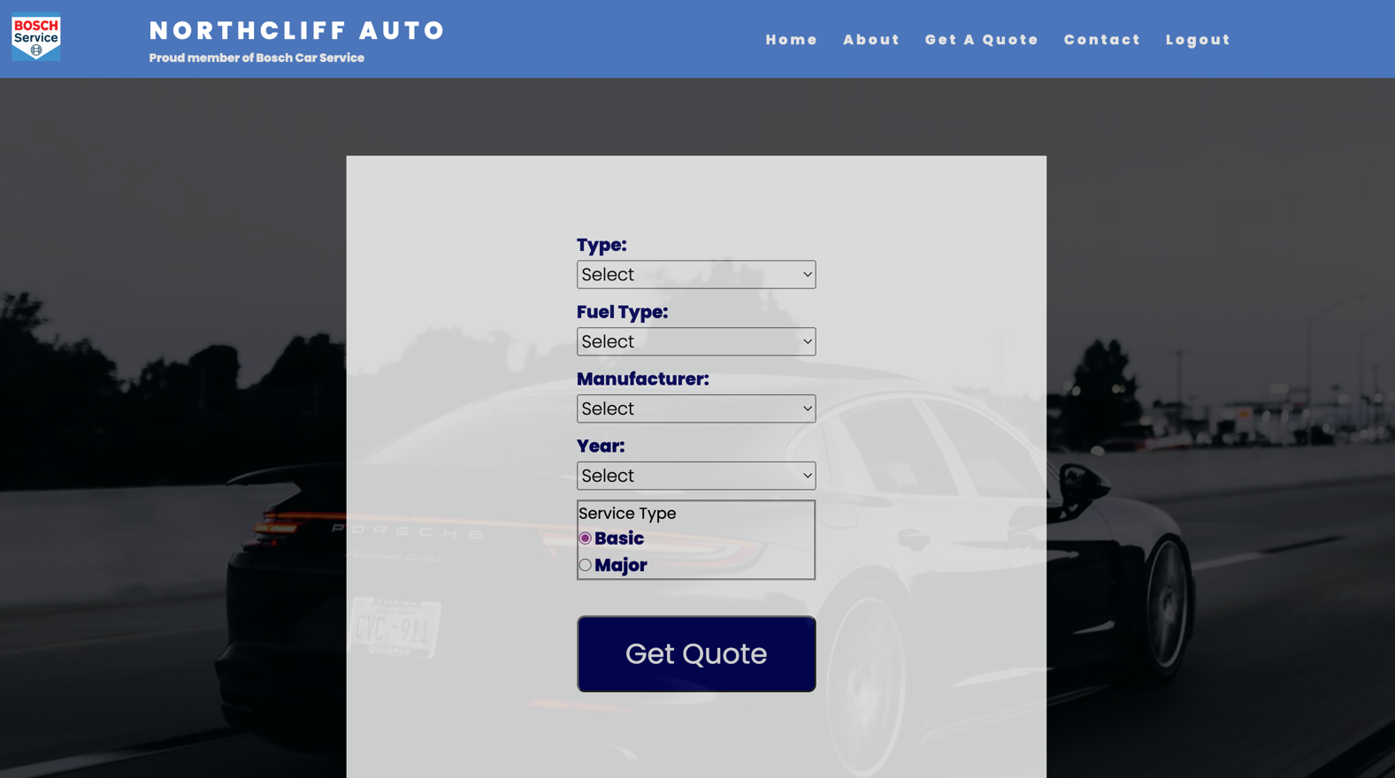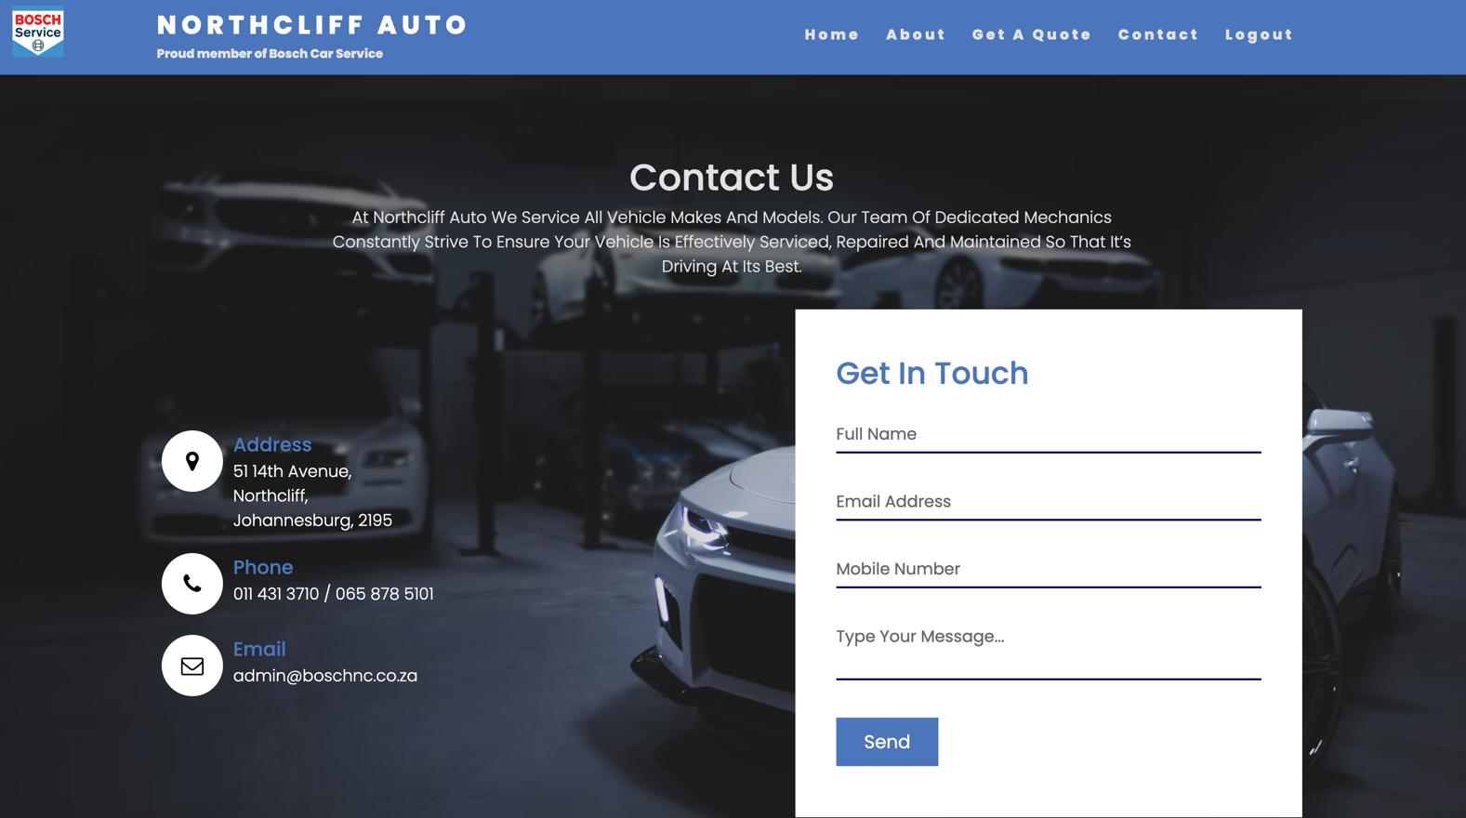

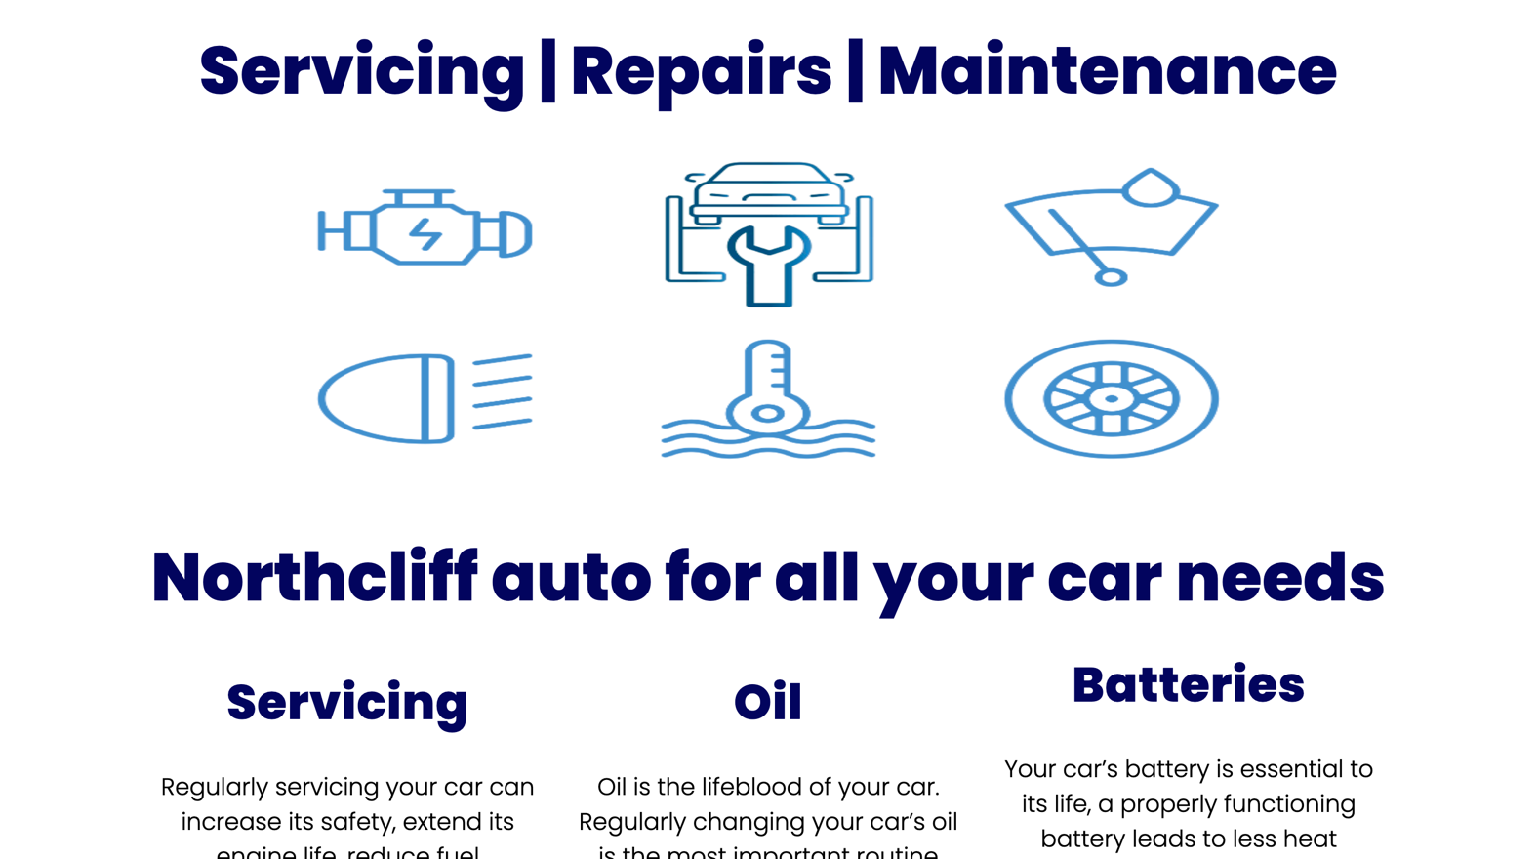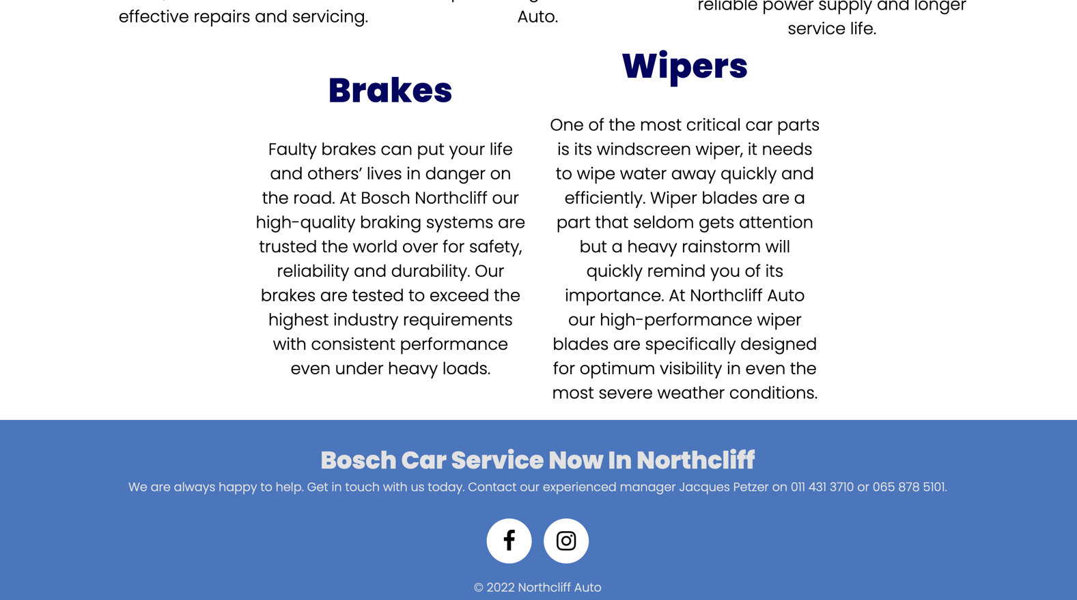

**Responsive Layout:**

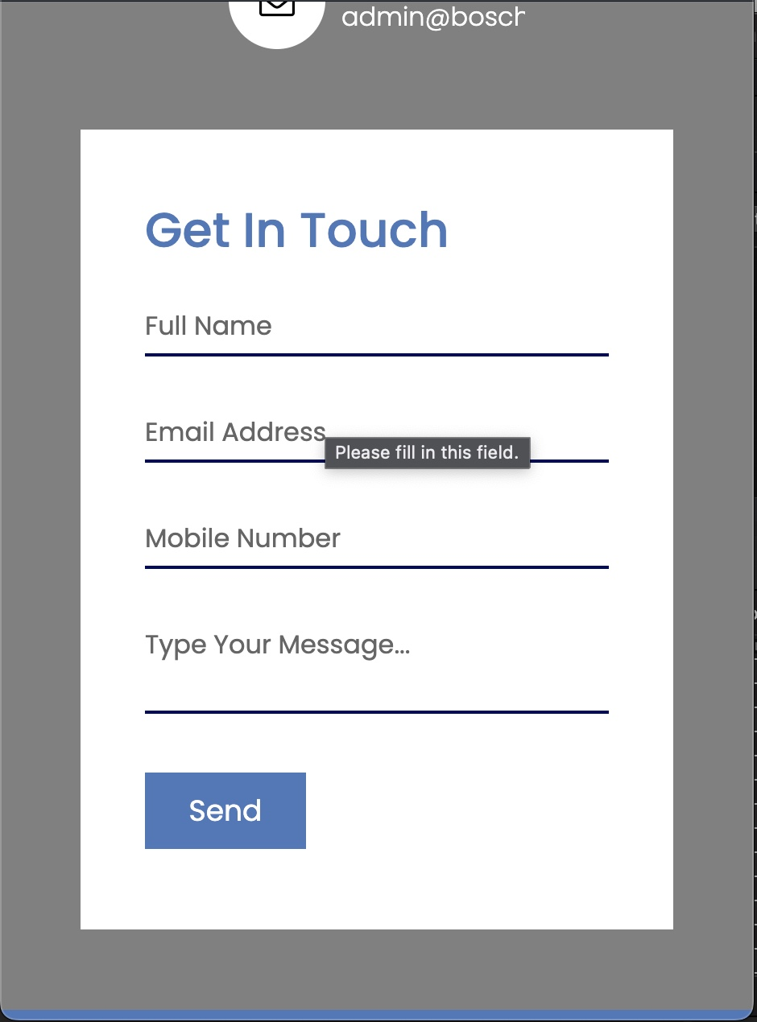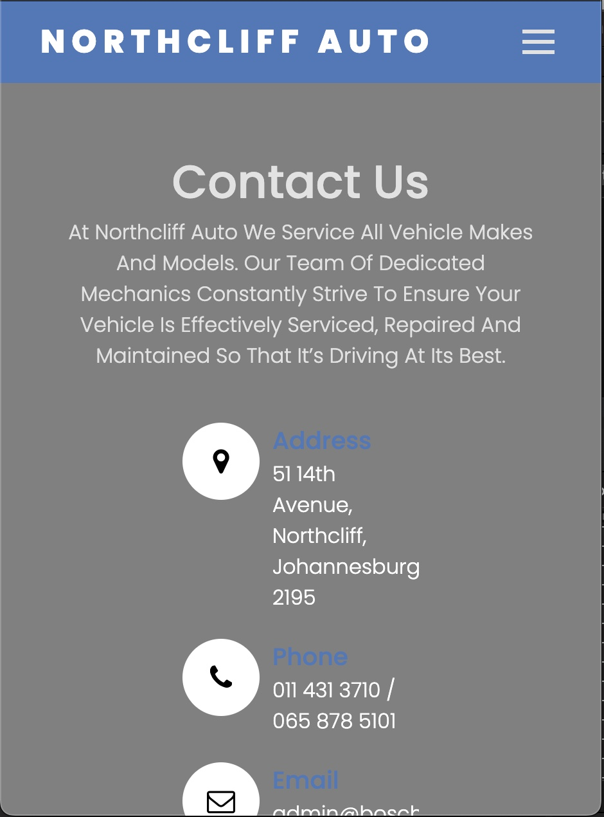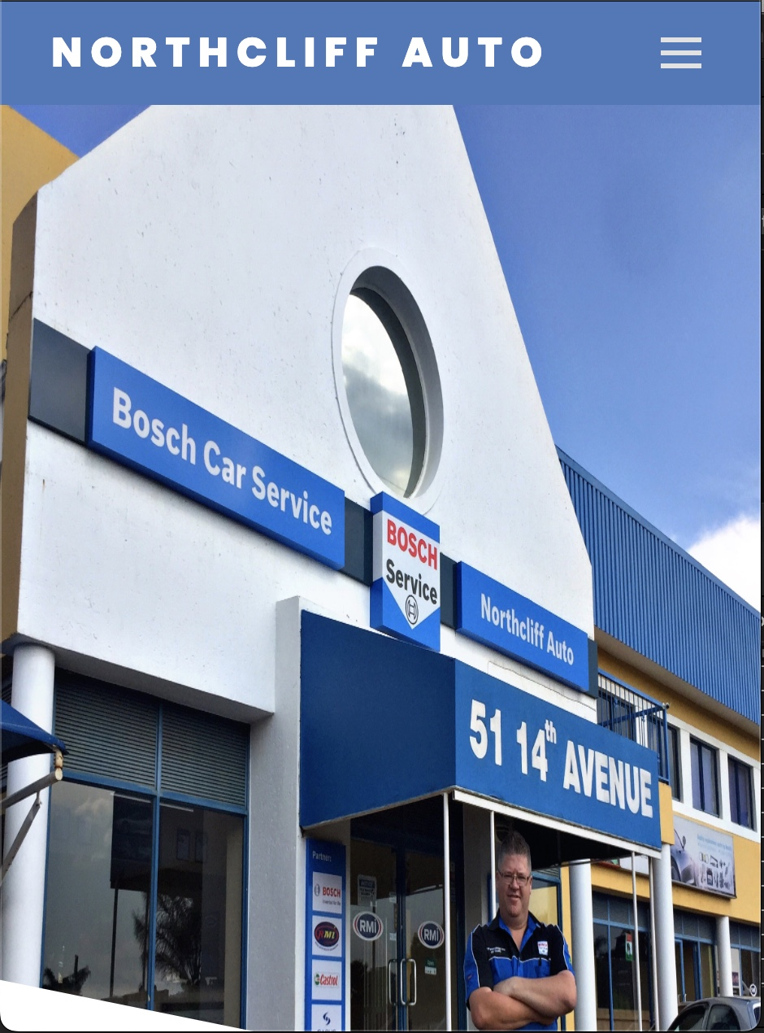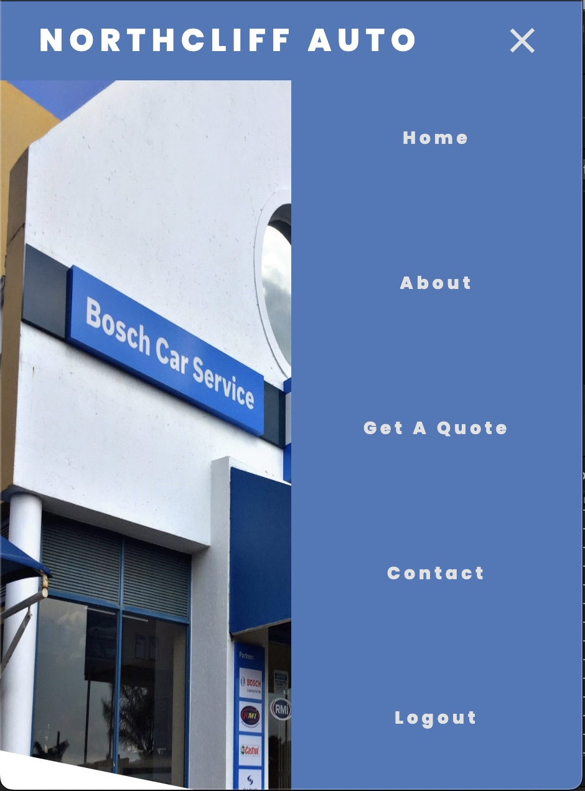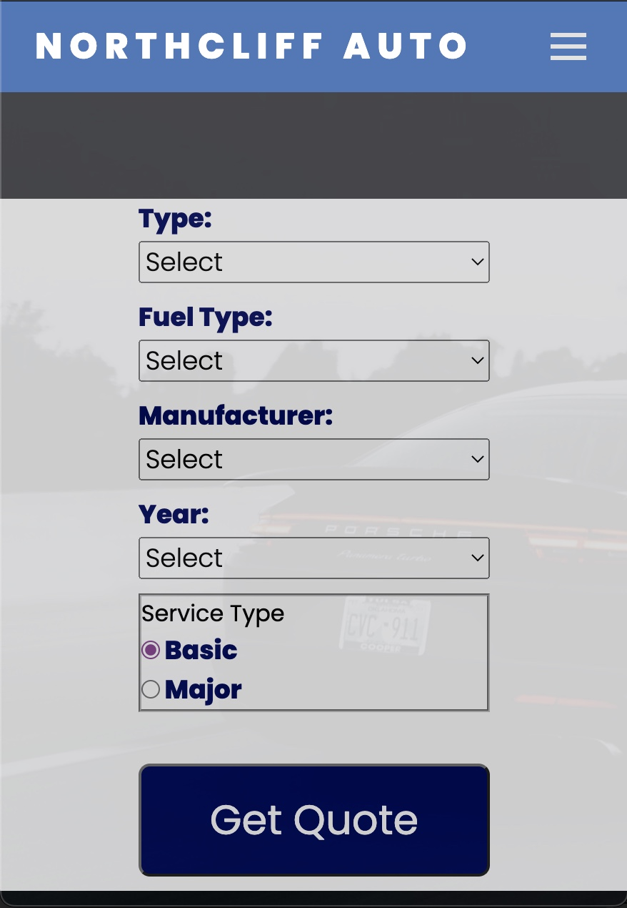

1. **Prototype 2.**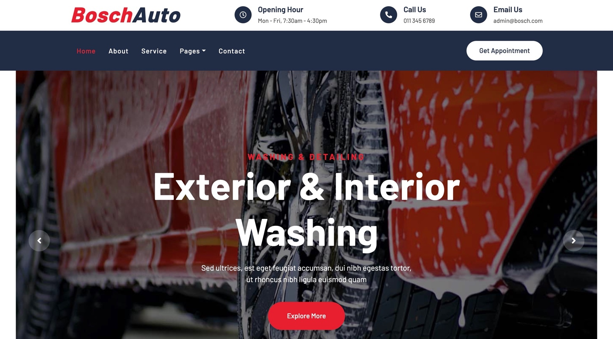

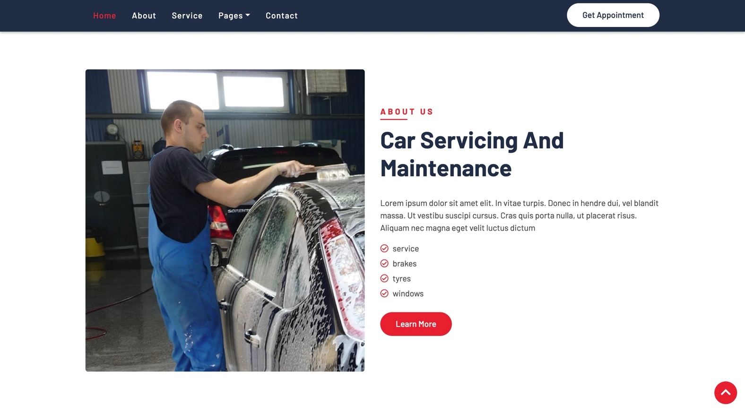

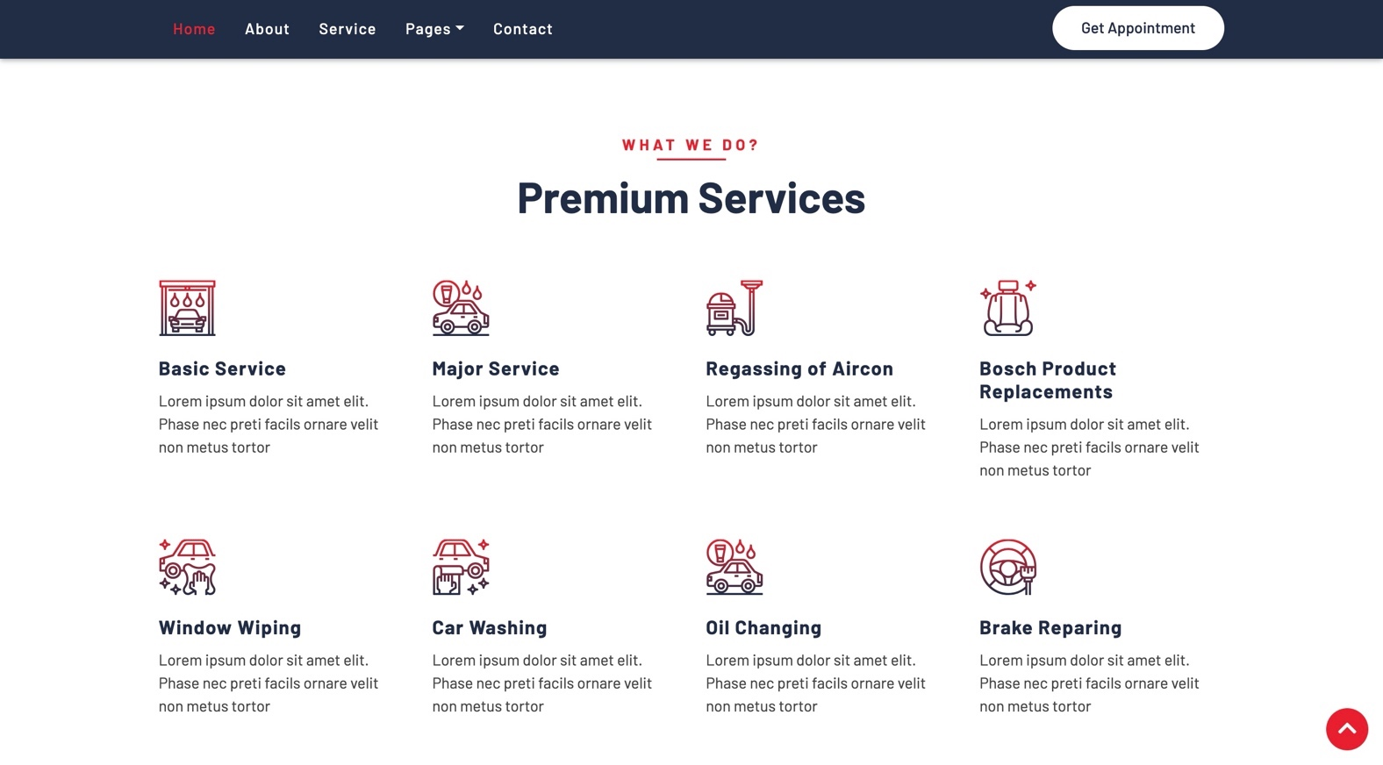

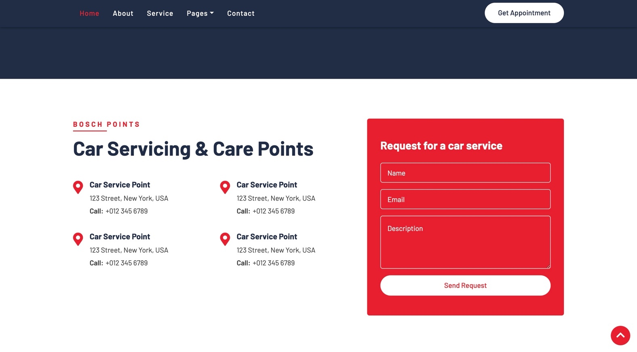

**Responsive Layout:**

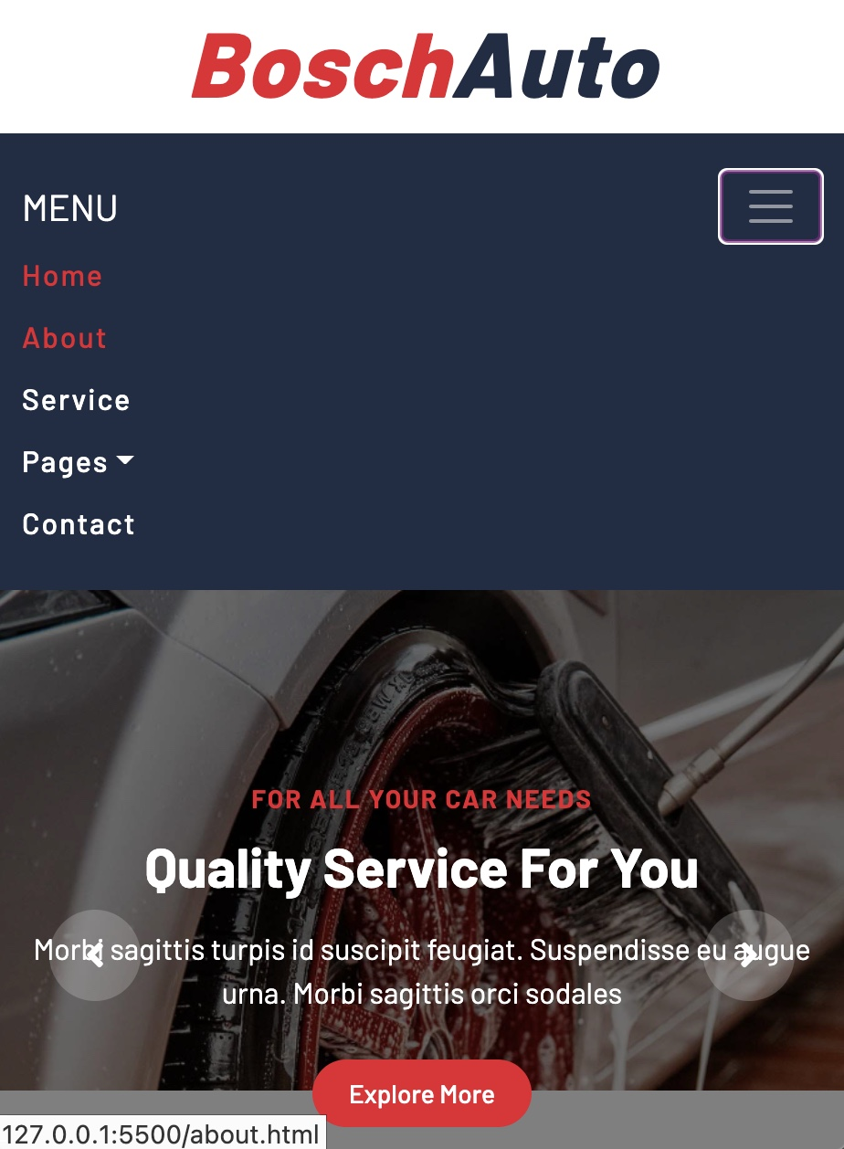



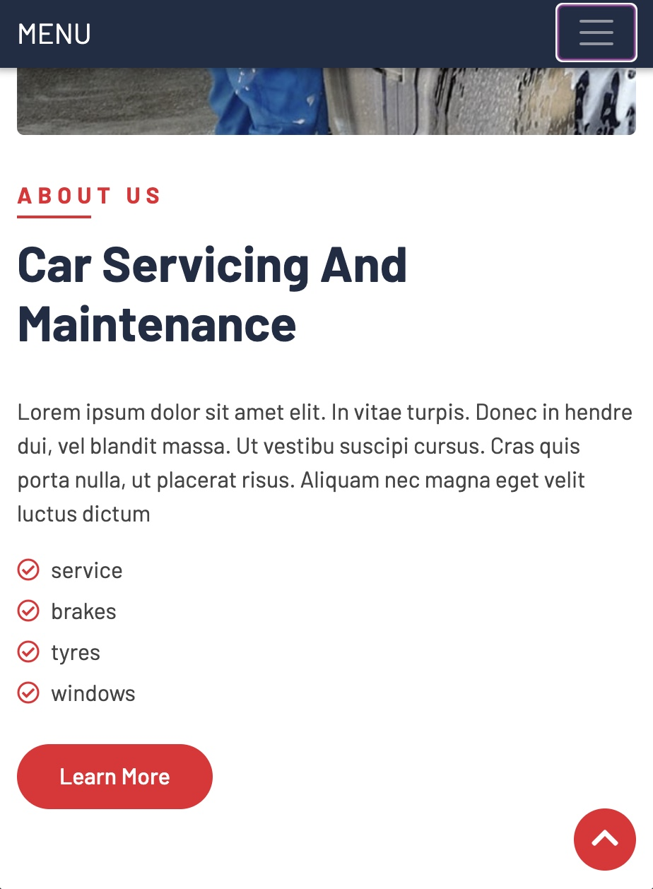

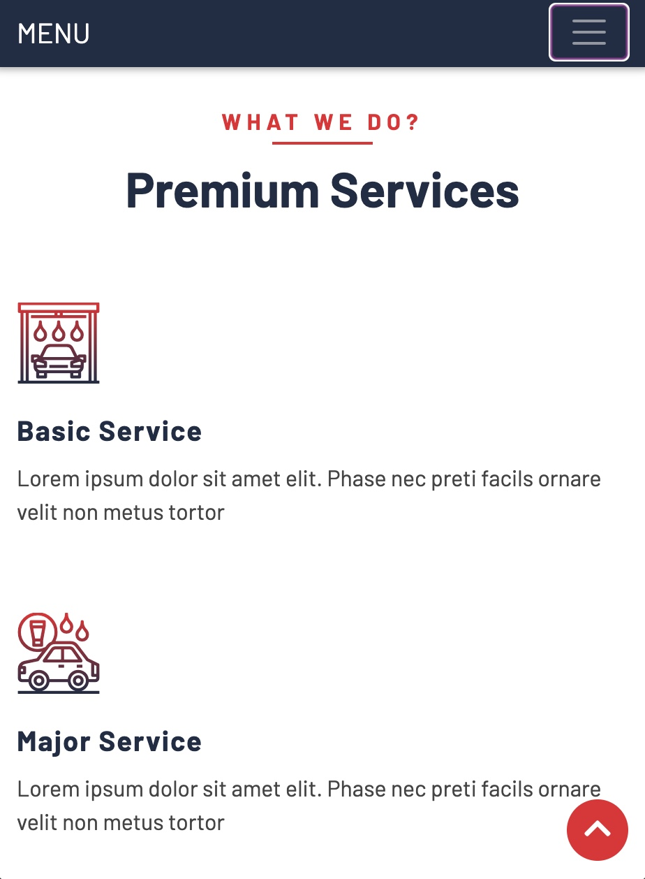

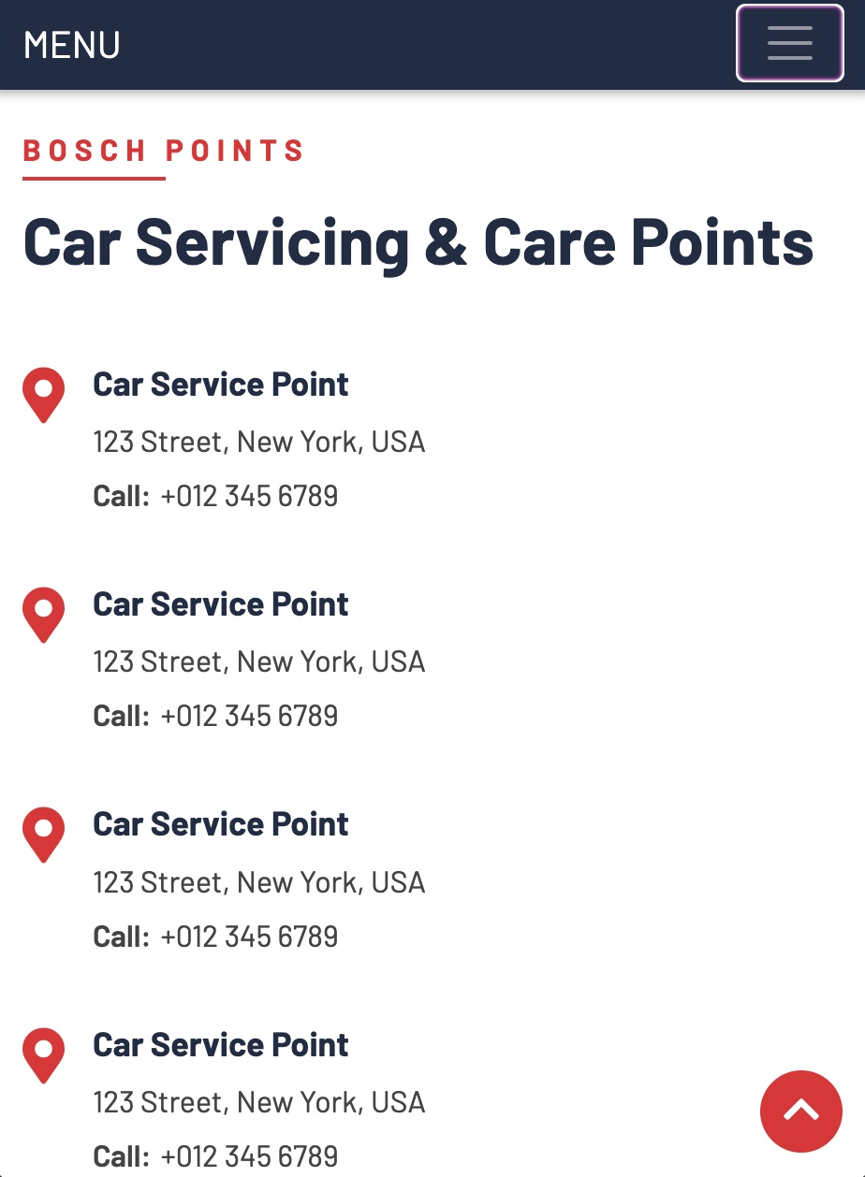

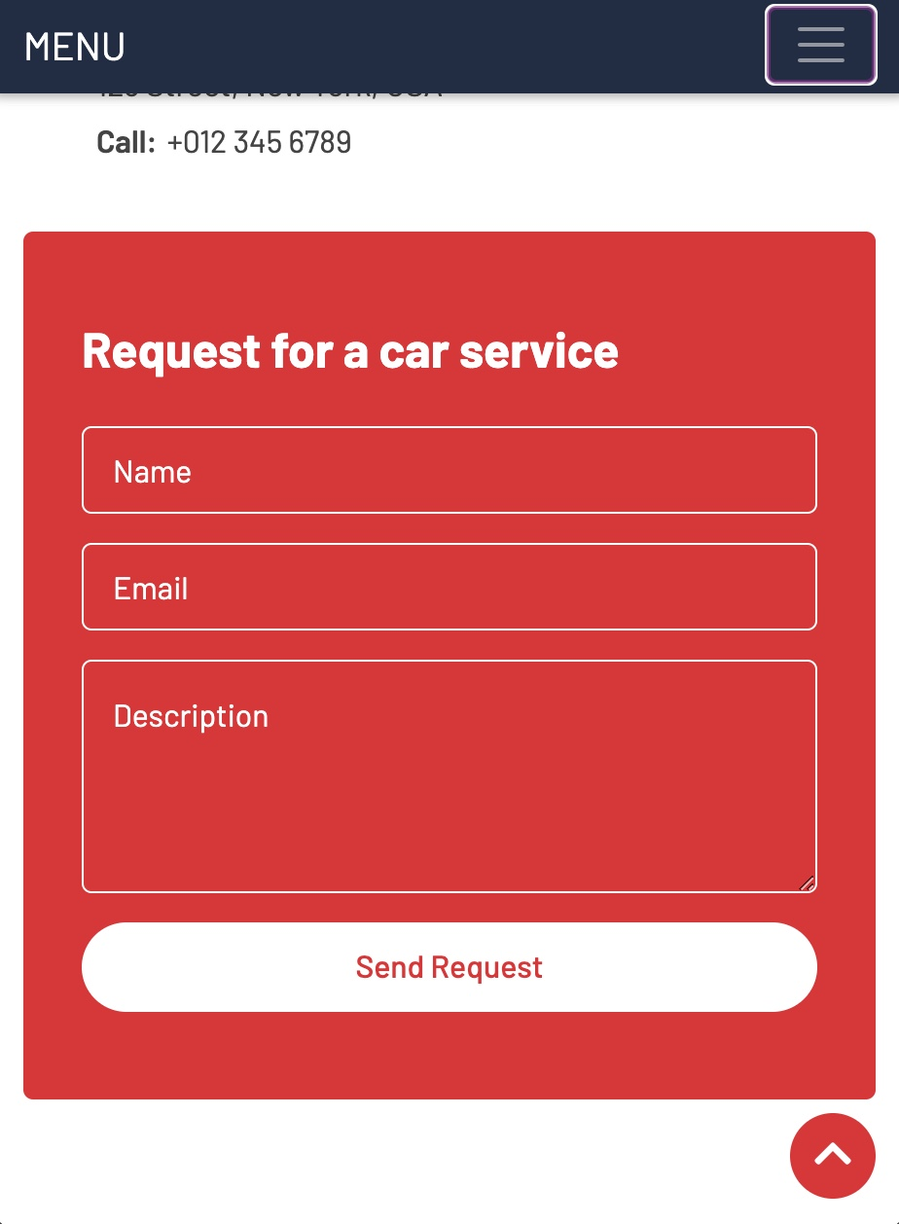

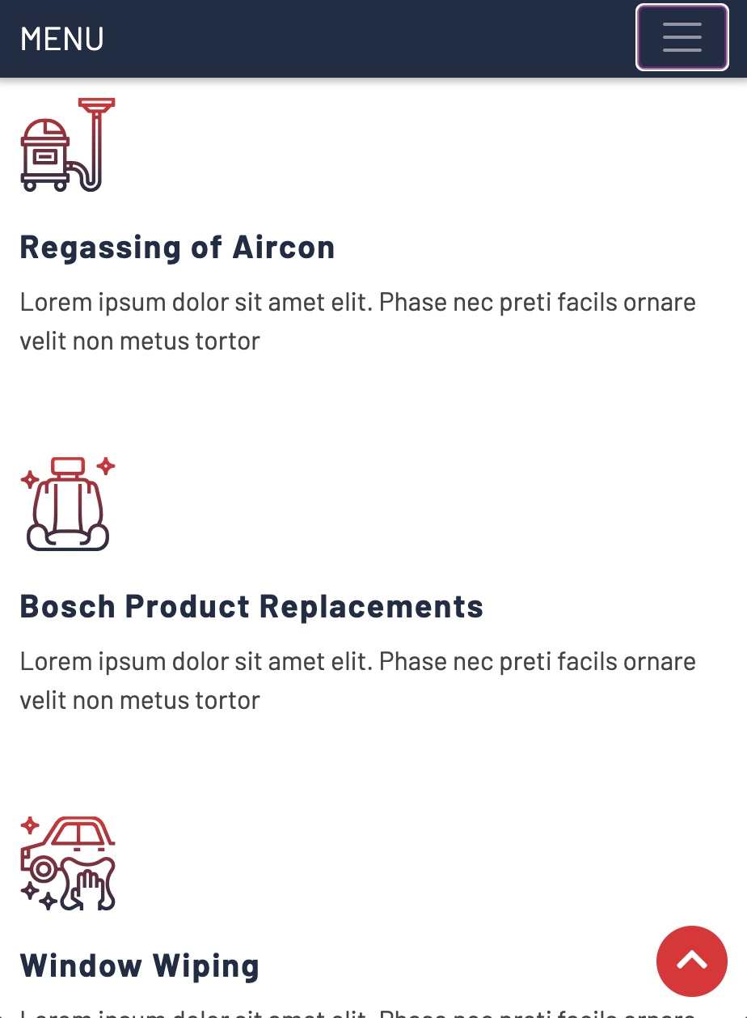

Your customer must select the prototype you should use for the website development.

# Designing

1. **Class Responsibility Collaborator (CRC) cards**

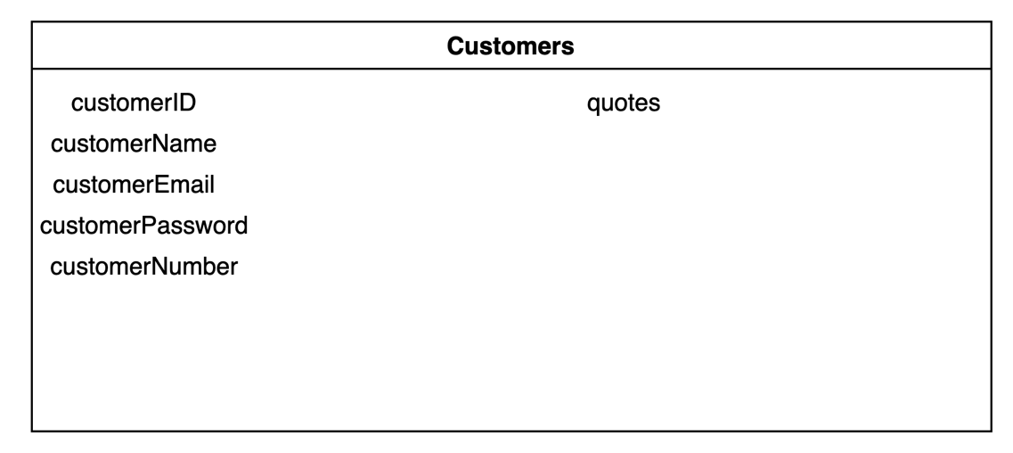

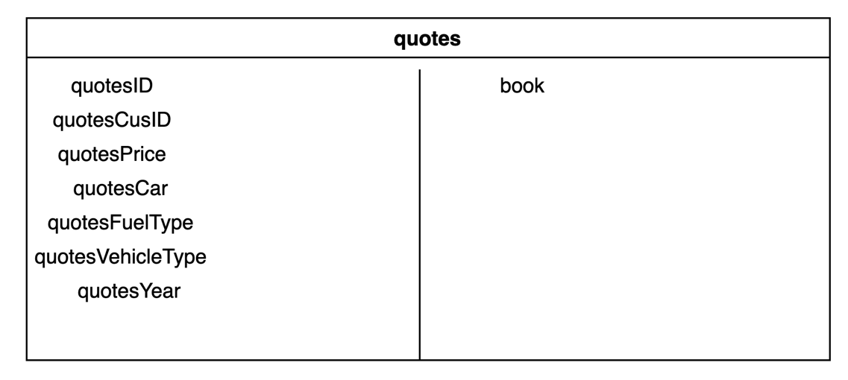

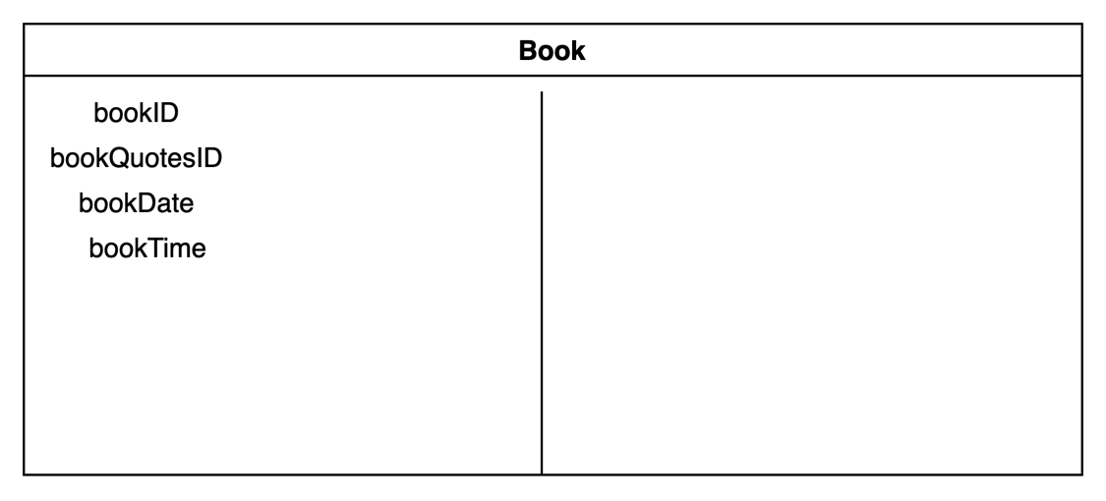

1. **Enhanced Entity Relationship Diagram (EERD)**

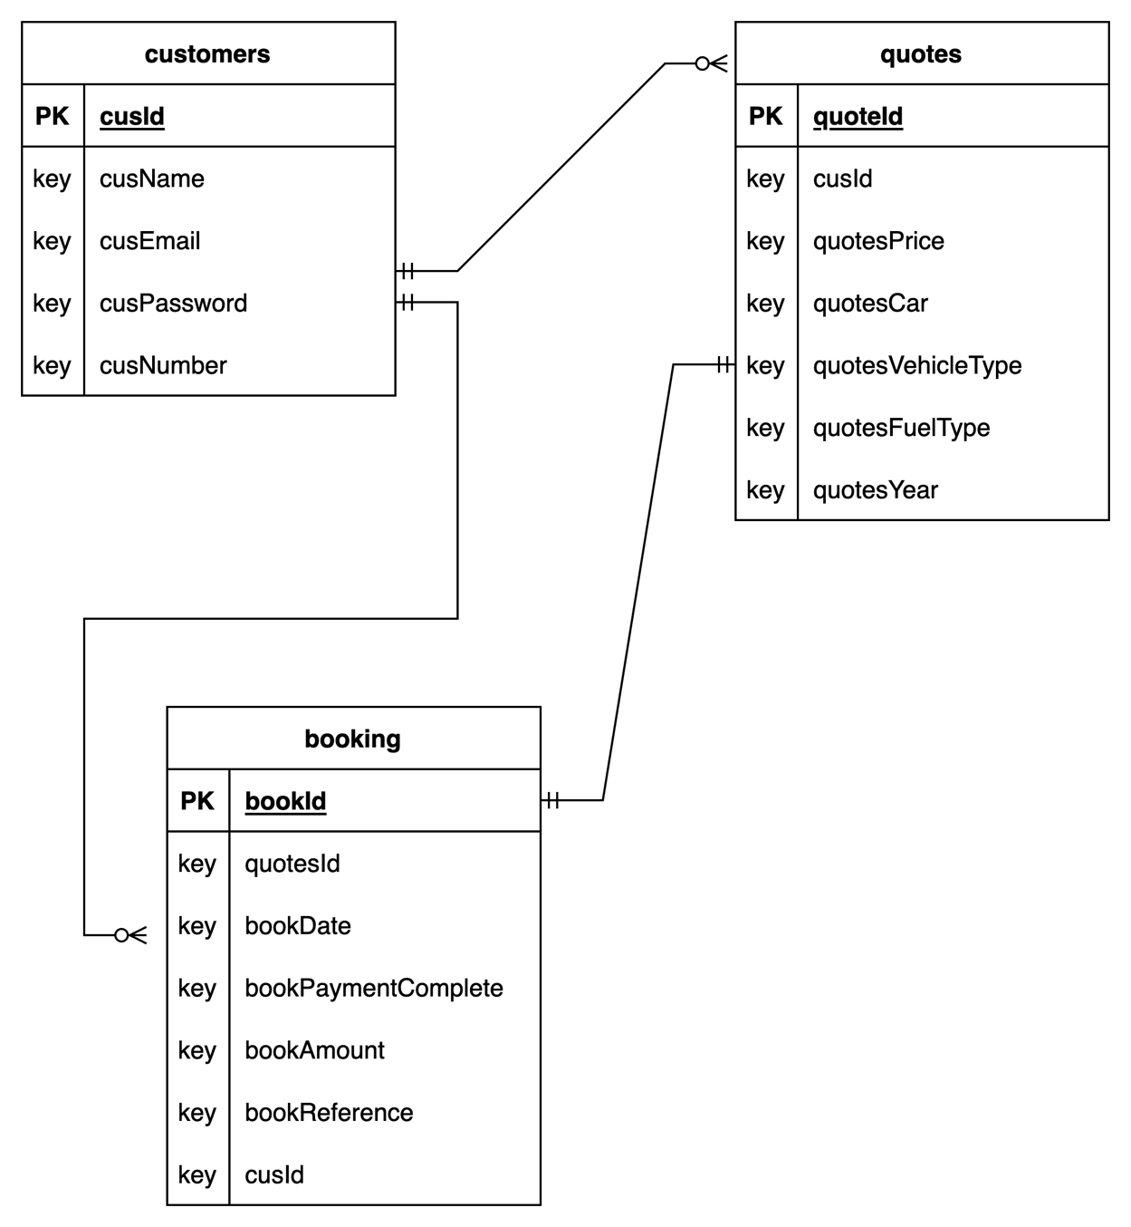

1. **Context Diagram**

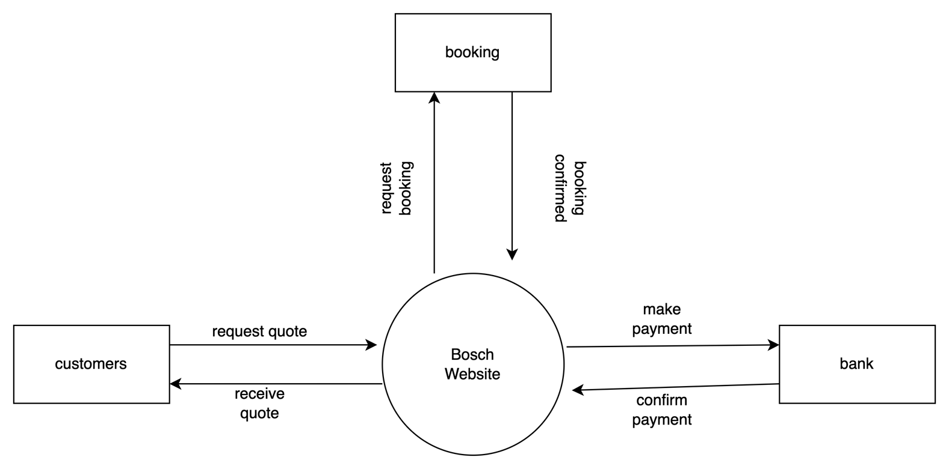

1. **Data Flow Diagram (DFD)**
2. 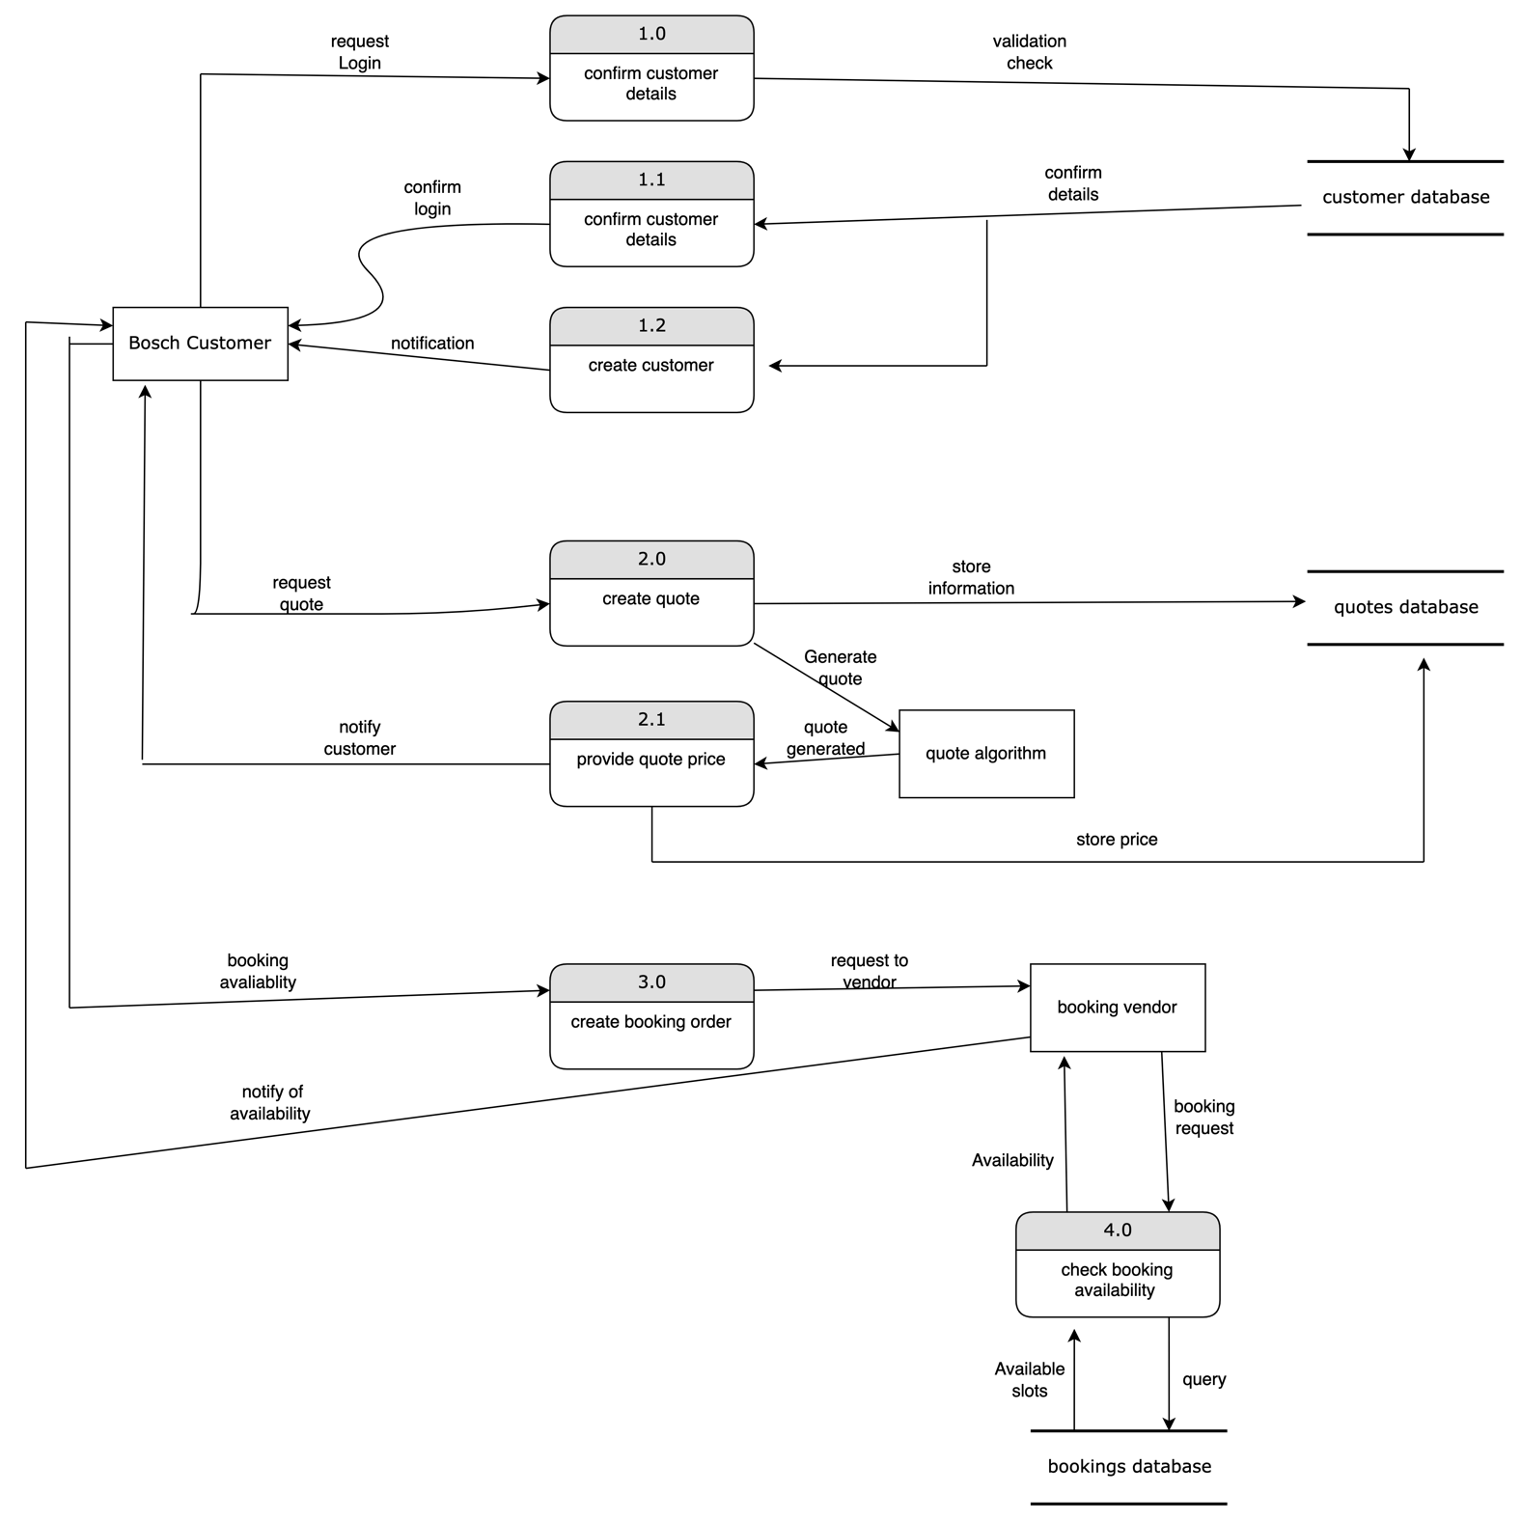
3. **Use Case Diagram**

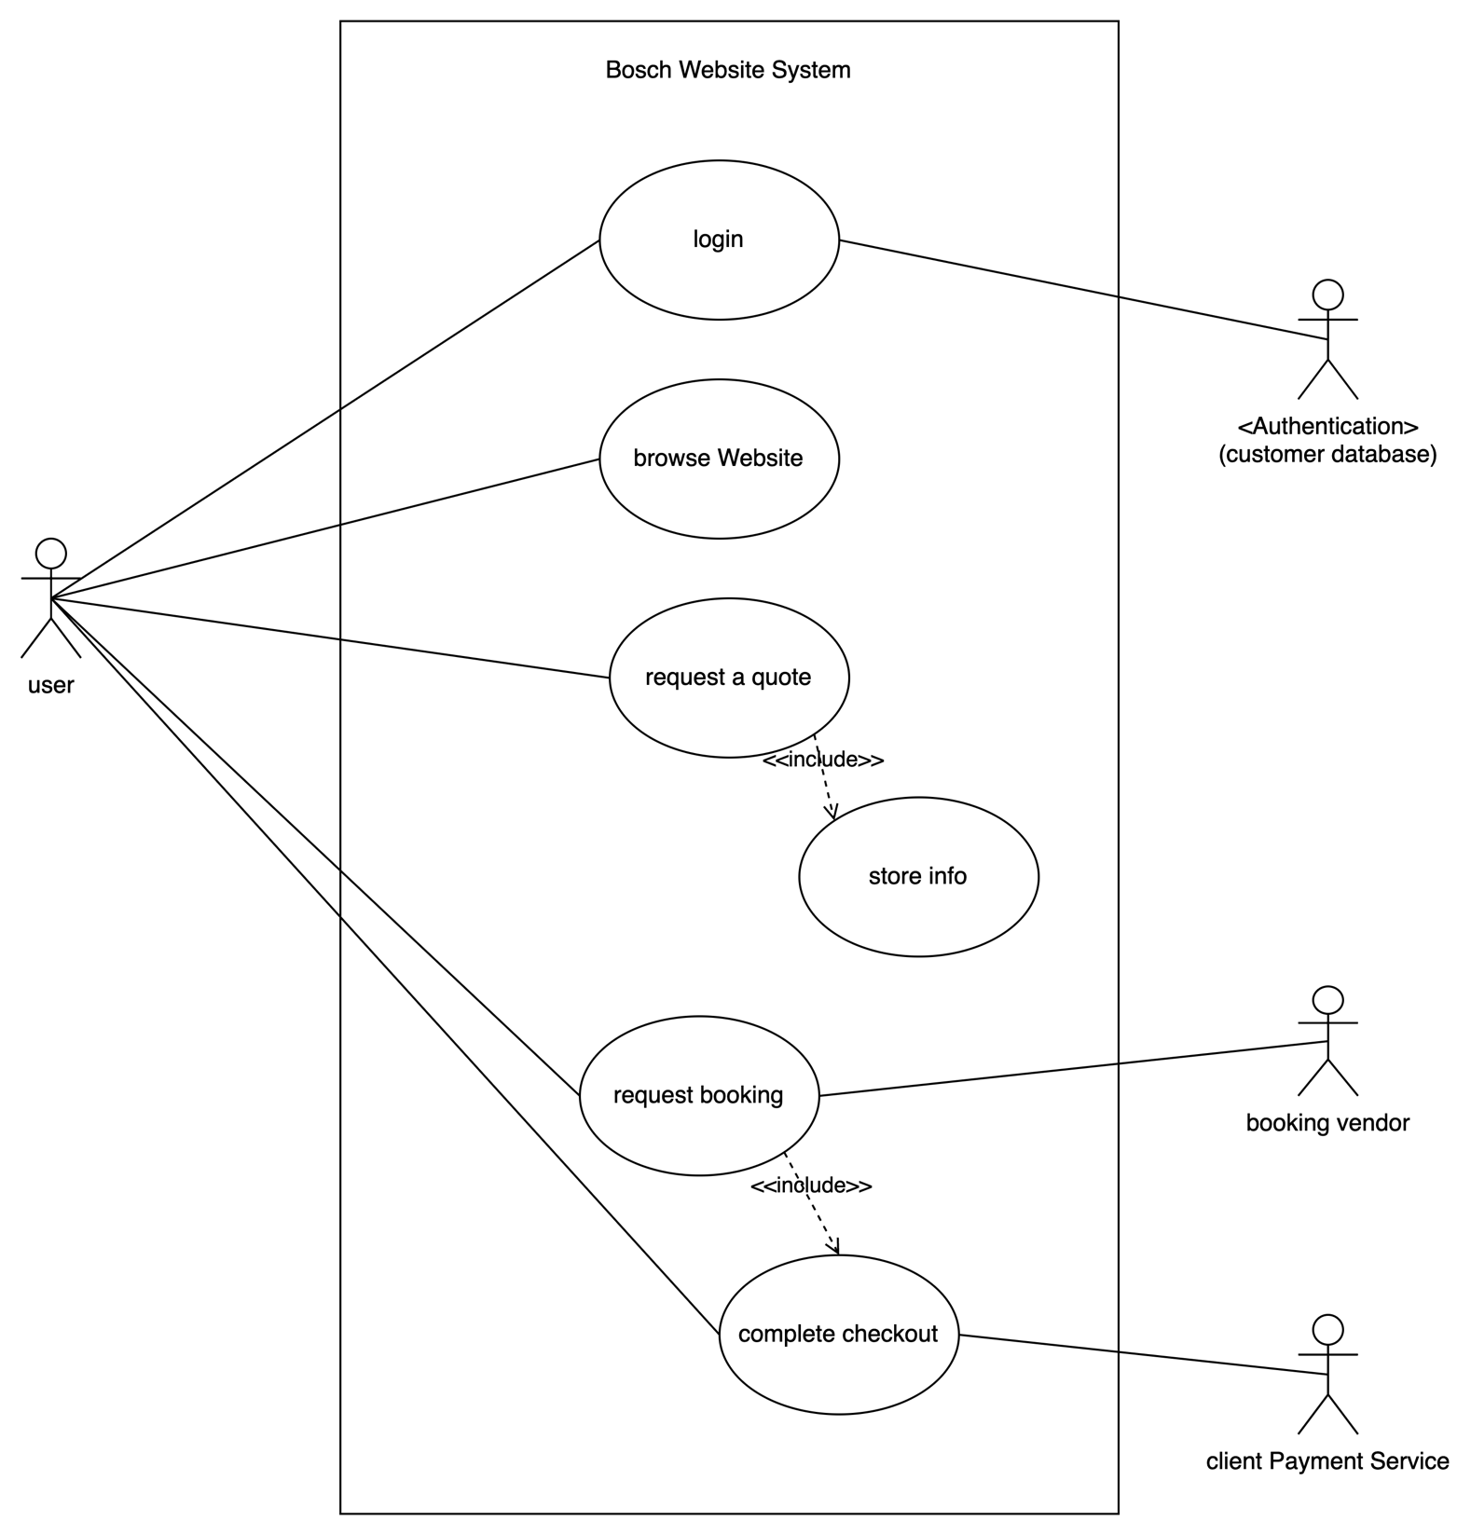

1. **Database Design**

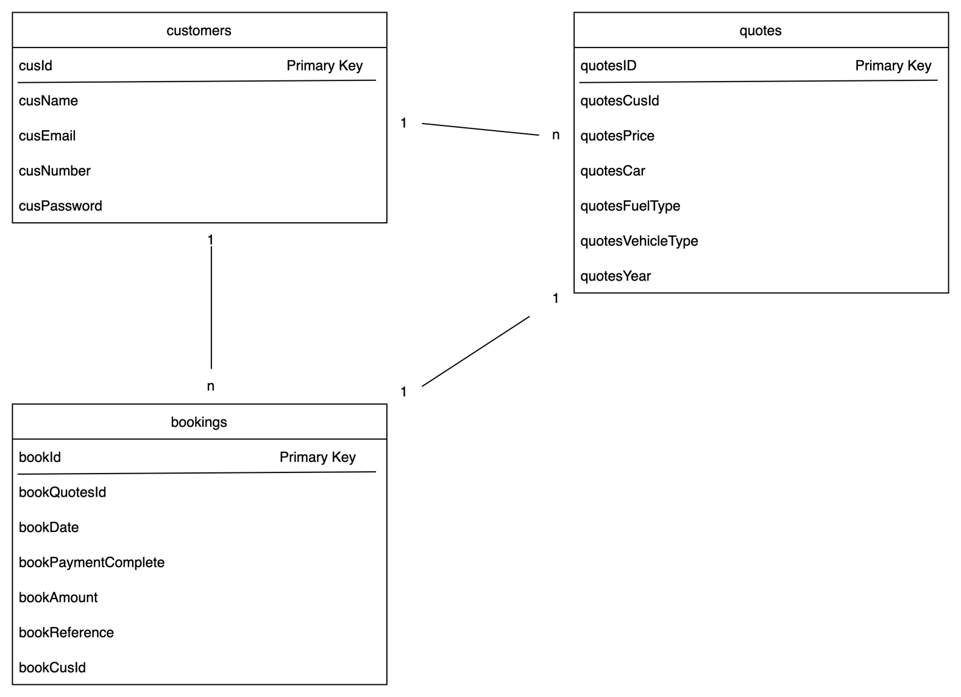

# Coding

Provide the screenshots and code samples of the final website. You do not have to print every code on your website. Use the following as guideline and explain what each sample code provided is used for on the website:

1. **Screenshots**



1. **Sample PHP Code**

Login php:

This code is used to authenticate user login and make sure the person has an account

<?php

include("connect.php");

*session_start*();

if (*isset*($_POST['submit'])) {

$email = *mysqli_real_escape_string*($conn, $_POST['email']);

$pass = *mysqli_real_escape_string*($conn, *md5*($_POST['password']));

$select_users = *mysqli_query*($conn, "SELECT * FROM `customers` WHERE cusEmail = '$email' AND cusPassword = '$pass'") or die('query failed!');

if (mysqli_num_rows($select_users) > 0) {

$row = *mysqli_fetch_assoc*($select_users);

$_SESSION['customer_name'] = $row['cusName'];

$_SESSION['customer_email'] = $row['cusEmail'];

$_SESSION['customer_id'] = $row['cusId'];

*header*('location:home.php');

} else {

$message[] = 'incorrect password or email entered!';

}

}

?>

Register php :

Used to register a user on the database and make sure details are correct.

<?php

include("connect.php");

if (*isset*($_POST['submit'])) {

$name = *mysqli_real_escape_string*($conn, $_POST['name']);

$email = *mysqli_real_escape_string*($conn, $_POST['email']);

$pass = *mysqli_real_escape_string*($conn, *md5*($_POST['password']));

$cpass = *mysqli_real_escape_string*($conn, *md5*($_POST['cpassword']));

$select_users = *mysqli_query*($conn, "SELECT * FROM `customers` WHERE cusEmail = '$email' AND cusPassword = '$pass'") or die('query failed!');

if (mysqli_num_rows($select_users) > 0) {

$message[] = 'user already exists';

} else {

if ($pass != $cpass) {

$message[] = 'passwords do not match';

} elseif (!*filter_var*($email, *FILTER_VALIDATE_EMAIL*)) {

$message[] = 'invalid email entered';

} else {

*mysqli_query*($conn, "INSERT INTO `customers` (cusName, cusEmail , cusPassword) VALUES ('$name', '$email', '$pass')") or die('query failed');

$message[] = 'registered successfully!';

*header*('location:login.php');

}

}

}

?>

1. **Sample HTML Code**

**Home page html code: used to decorate the home page from the nav bar to the footer**

<!Doctype html>

<html>

<head>

<meta charset="UTF-8">

<meta name="viewport" content="Width=device-width, initial-scale=1.0">

<meta http-equiv="X-UA-Compatible" content="ie=edge">

<link rel="stylesheet" href="css/style.css">

<link href="https://fonts.googleapis.com/css2?family=Poppins:wght@500&display=swap" rel="stylesheet">

<link rel="stylesheet" href="https://cdnjs.cloudflare.com/ajax/libs/font-awesome/4.7.0/css/font-awesome.min.css">

<link rel="stylesheet" href="css/banner.css">

<title>Bosch Website</title>

</head>

<body>

<nav>

<div class="logo">

<img src="./images/Bosch_Logo.png" alt="" class="logoImg">

<h4>Northcliff Auto</h4>

<h6>Proud member of Bosch Car Service</h6>

</div>

<ul class="nav-links">

<li><a href="home.php" class="active">Home</a></li>

<li><a href="about.php">About</a></li>

<li><a href="quote.php">Get A Quote</a></li>

<li><a href="contact.php">Contact</a></li>

<li><a href="login.php">Logout</a></li>

</ul>

<div class="burger">

<div class="line1"></div>

<div class="line2"></div>

<div class="line3"></div>

</div>

</nav>

<div class="slider">

<div class="sliderItem">

<img src="./images/bosch_home.jpeg" alt="" class="sliderImg">

</div>

</div>

<div class="intro">

<div class="introTitle">

<h3 class="introHeading">welcome <span><?php *echo* $customer_name; ?></span> to northcliff auto</h3>

<h1 class="introSubHeading">Get a quote or book a service. We are a proud member of Bosch Car Service.</h1>

<p class="introPara">You’re in good hands when it comes to vehicle services, maintenance, repairs and advice. Our experienced team of motor enthusiasts are fully equipped with the latest automotive technology to efficiently deal with all vehicle makes and models to get them back on the road as soon as possible.

At Northcliff Auto, your driving safety is our top priority that's why with every service we will check your battery, tyres, engine, brakes, lights, windscreen wipers, oil, fluids, exhaust and air conditioning.</p>

</div>

</div>

<div class="services">

<div class="serviceSection">

<div class="serviceCard">

<img src="./images/servicing_car.avif" alt="engine" class="serviceImg">

<h3 class="serviceType">servicing</h3>

<p class="serviceLearn"><a href="#">learn more</a></p>

</div>

<div class="serviceCard">

<img src="./images/bosch_working_2.jpeg" alt="brakes" class="serviceImg">

<h3 class="serviceType">brakes</h3>

<p class="serviceLearn"><a href="#">learn more</a></p>

</div>

<div class="serviceCard">

<img src="./images/oil_pour.jpg" alt="oil pour" class="serviceImg">

<h3 class="serviceType">oil change</h3>

<p class="serviceLearn"><a href="#">learn more</a></p>

</div>

<div class="serviceCard">

<img src="./images/bosch_products.jpeg" alt="products" class="serviceImg">

<h3 class="serviceType">windscreen</h3>

<p class="serviceLearn"><a href="#">learn more</a></p>

</div>

</div>

</div>

<div class="listSection">

<div class="lists">

<div class="list1">

<div class="listBox">

<div class="iconbox">

<i class="fa fa-check" aria-hidden="true"></i>

</div>

<h2>Major Services</h2>

</div>

<div class="listBox">

<div class="iconbox">

<i class="fa fa-check" aria-hidden="true"></i>

</div>

<h2>Minor Services</h2>

</div>

<div class="listBox">

<div class="iconbox">

<i class="fa fa-check" aria-hidden="true"></i>

</div>

<h2>All Auto Elctrical Work</h2>

</div>

<div class="listBox">

<div class="iconbox">

<i class="fa fa-check" aria-hidden="true"></i>

</div>

<h2>Vehicle Diagonostics & Report</h2>

</div>

</div>

<div class="list2">

<div class="listBox">

<div class="iconbox">

<i class="fa fa-check" aria-hidden="true"></i>

</div>

<h2>Battery Replacement</h2>

</div>

<div class="listBox">

<div class="iconbox">

<i class="fa fa-check" aria-hidden="true"></i>

</div>

<h2>Brakes & Suspension</h2>

</div>

<div class="listBox">

<div class="iconbox">

<i class="fa fa-check" aria-hidden="true"></i>

</div>

<h2>Cambelt Servicing</h2>

</div>

<div class="listBox">

<div class="iconbox">

<i class="fa fa-check" aria-hidden="true"></i>

</div>

<h2>Wheel Balancing & Alignment</h2>

</div>

</div>

</div>

</div>

<div class="yearSection">

<div class="yearText">

<div class="text">

<h3>20 years of experience</h3>

<p>“Myself and my dedicated team are always ready to assist you with all your vehicle needs, there’s no job too big or small for us!” says operating partner Jacques Petzer, who has over 20 years worth of experience in vehicles and servicing in the area</p>

</div>

<div class="jacq">

<img src="./images/workshop.jpeg" alt="partner">

</div>

</div>

</div>

<div class="choose">

<h2>why choose us?</h2>

<p>Northcliff Auto is a proud member of Bosch Car Service</p>

<div class="chooseSection">

<div class="item">

<img src="./images/rmi_choose.png" alt="rmi approved">

</div>

<div class="item">

<img src="./images/miwa_choose.png" alt="miwa approved">

</div>

<div class="item">

<img src="./images/aa_icon_approved.png" alt="aa approved">

</div>

</div>

<div class="chooseCertif">

<div class="certif">

<img src="./images/RMI approved.jpeg" alt="rmi certificate">

</div>

<div class="certif">

<img src="./images/bosch_graded_work.jpeg" alt="miwa certificate">

</div>

<div class="certif">

<img src="./images/AA_approved.jpeg" alt="aa certificate">

</div>

</div>

</div>

<div class="serviceBanner">

<h2>is your car due for it's service</h2>

<p>At Northcliff Auto we service all vehicle makes and models. Our team of dedicated mechanics constantly strive to ensure your vehicle is effectively serviced, repaired and maintained so that it’s driving at its best. Our state of the art diagnostic equipment is designed to diagnose a problem quickly and efficiently to avoid problems turning into major expenses.</p>

<button type="submit" class="serviceBtn" id="quoteBtn" onclick="nextPage()">Get A Quote</button>

</div>

<!-- *********************************** Review Section **************************************** -->

<div class="reviews">

<h2>Reviews</h2>

<div class="reviewItems">

<div class="line"></div>

<div class="review">

<img src="./images/quote_image.png" alt="">

<h3>The only place I would recommend taking your vehicle.Fantastic and professional service.</h3>

<h6>- Callen Valkenburg</h6>

</div>

<div class="line"></div>

<div class="review">

<img src="./images/quote_image.png" alt="">

<h3>Very professional. It’s the only place I trust to take my car for any kind of repair or check.</h3>

<h6>- Jessica Franklin</h6>

</div>

<div class="line"></div>

<div class="review">

<img src="./images/quote_image.png" alt="">

<h3>The only place I would recommend taking your vehicle.Fantastic and professional service.</h3>

<h6>- Annemarie Stierlin</h6>

</div>

</div>

</div>

<footer class="footer">

<div class="footHeading">

<h2>bosch car service now in northcliff</h2>

<p>We are always happy to help. Get in touch with us today. Contact our experienced manager Jacques Petzer on 011 431 3710 or 065 878 5101.</p>

</div>

<div class="socials">

<div class="socialBox" id="facebook"><i class="fa fa-facebook" aria-hidden="true"></i></div>

<div class="socialBox" id="instagram"><i class="fa fa-instagram" aria-hidden="true"></i></div>

</div>

<div class="footClose">

<h2>© 2022 northcliff auto</h2>

</div>

</footer>

**Footer section on every page**

<footer class="footer">

<div class="footHeading">

<h2>bosch car service now in northcliff</h2>

<p>We are always happy to help. Get in touch with us today. Contact our experienced manager Jacques Petzer on 011 431 3710 or 065 878 5101.</p>

</div>

<div class="socials">

<div class="socialBox" id="facebook"><i class="fa fa-facebook" aria-hidden="true"></i></div>

<div class="socialBox" id="instagram"><i class="fa fa-instagram" aria-hidden="true"></i></div>

</div>

<div class="footClose">

<h2>© 2022 northcliff auto</h2>

</div>

</footer>

**Nav section on every page:**

<nav>

<div class="logo">

<img src="./images/Bosch_Logo.png" alt="" class="logoImg">

<h4>Northcliff Auto</h4>

<h6>Proud member of Bosch Car Service</h6>

</div>

<ul class="nav-links">

<li><a href="home.php" class="active">Home</a></li>

<li><a href="about.php">About</a></li>

<li><a href="quote.php">Get A Quote</a></li>

<li><a href="contact.php">Contact</a></li>

<li><a href="login.php">Logout</a></li>

</ul>

<div class="burger">

<div class="line1"></div>

<div class="line2"></div>

<div class="line3"></div>

</div>

</nav>

**Contact form section:**

**Used to make the form on the contact.php page**

<div class="contactForm">

<form action="" method="post">

<h2>get in touch</h2>

<div class="inputbox">

<input type="text" name="name-contact" id="name-contact" required>

<span>Full Name</span>

</div>

<div class="inputbox">

<input type="text" name="email-second" id="email-second" required>

<span>Email Address</span>

</div>

<div class="inputbox">

<input type="text" name="mobile" id="mobile" required>

<span>Mobile Number</span>

</div>

<div class="inputbox">

<textarea required="required" name="msg" id="msg"></textarea>

<span>Type Your Message...</span>

</div>

<div class="inputbox">

<input type="submit" value="Send" name="send" onsubmit="sendEmail(); reset(); return *false*">

</div>

</form>

</div>

1. **Sample JavaScript Code**

**JavaScript used to send email on contact page when form is submitted:**

<script src="https://smtpjs.com/v3/smtp.js"></script>

<script>

*function* sendEmail() {

Email.send({

Host: "smtp.gmail.com",

Username: "2610dylan@gmail.com",

Password: "2101taryn",

To: '2610dylan@gmail.com',

From: document.getElementById('email-second').value,

Subject: "New Contact Form Enquiry",

Body: "Name: " + document.getElementById('name-contact').value + "<br> Email: " + document.getElementById('email-second').value + "<br> Number: " + document.getElementById('number').value + "<br> Message: " + document.getElementById('msg').value

}).then(

message *=>* alert("Message Sent Successfully")

);

}

</script>

**Used to style the navbar with a burger icon and vertical map for responsiveness:**

*const* navSlide = () *=>* {

*const* burger = document.querySelector('.burger');

*const* nav = document.querySelector('.nav-links');

*const* navLinks = document.querySelectorAll('.nav-links li');

burger.addEventListener('click', () *=>* {

nav.classList.toggle('nav-active');

//animate links

navLinks.forEach((link, index)*=>*{

if(link.style.animation) {

link.style.animation = '';

} else {

link.style.animation = `navLinkFade 0.5s ease forwards ${index / 7 + 0.3}s`;

}

});

//Animation for menu

burger.classList.toggle('toggle');

});

}

**Snippet of JavaScript Used to generate quote:**

//Quote Screen

//Variables

*const* form = document.getElementById('request-quote');

*const* manuCar = document.getElementById('manu');

*const* html = new htmlUI();

//event listener

*function* eventListeners() {

document.addEventListener('DOMContentLoaded', *function*() {

html.displayYears();

});

//When form is submitted

form.addEventListener('submit', *function*(e) {

e.preventDefault();

*const* type = document.getElementById('type').value;

*const* fuel = document.getElementById('ftype').value;

*const* manufact = document.getElementById('manu').value;

*const* year = document.getElementById('year').value;

//read the radio buttons

*const* service = document.querySelector('input[name="level"]:checked').value;

if ( type === '' || fuel === '' || manufact === '' || year === '' || service === '') {

html.displayError('All the fields are mandatory!');

} else {

//Clear old quotes

*const* prevResult = document.querySelector('#result div');

if (prevResult != *null*) {

prevResult.remove();

}

// Make the quotation

*const* serviceObj = new Service(type, fuel, manufact, year, service);

*const* price = serviceObj.calculateQuotation(serviceObj);

//print the result

html.showResults(price, serviceObj);

}

});

}

//Objects

//Quotation

*function* Service(type, fuel, manu, year, service) {

*this*.type = type;

*this*.fuel = fuel;

*this*.manu = manu;

*this*.year = year;

*this*.service = service;

}

//calculate the price of service

Service.prototype.calculateQuotation = *function*(serviceObj) {

*let* price;

*const* base = 1200;

*const* consumables = 300;

*const* lightVeh = 200;

*const* Truck = 500;

*const* petrol = 200;

*const* Diesel = 300;

*const* electric = 500;

*const* basic = 400;

*const* major = 1000;

*const* carCat1 = 1000;

*const* carCat2 = 800;

*const* carCat3 = 600;

price = base + consumables;

//get the type

*let* carType = serviceObj.type;

switch(carType) {

case 'Light':

price = price + lightVeh;

break;

case 'Truck':

price = price + Truck;

break;

}

//get the fuel

*let* carFuel = serviceObj.fuel;

switch(carFuel) {

case 'Petrol':

price = price + petrol;

break;

case 'Diesel':

price = price + Diesel;

break;

case 'Electric/Hybrid':

price = price + electric;

}

//get the year

*let* carYear = serviceObj.year;

//get the years difference

*const* difference = *this*.getYearDifference(carYear);

//every 5 years it will be 2% more

if (difference % 5 === 0 ) {

price = price + ((difference * 2) * price) / 100;

}

//get the level

*const* carLevel = serviceObj.service;

switch(carLevel) {

case 'basic':

price = price + basic;

break;

case 'major':

price = price + major;

break;

}

//get the manu

*const* carManu = serviceObj.manu;

switch(carManu) {

case '1':

price = price + carCat1;

break;

case '2':

price = price + carCat2;

break;

case '3':

price = price + carCat3;

break;

}

return price;

}

//returns diffrence in years

Service.prototype.getYearDifference = *function*(year) {

return new Date().getFullYear() - year;

}

//html section

*function* htmlUI() {}

htmlUI.prototype.displayYears = *function*() {

//max and minimum years

*const* max = new Date().getFullYear();

*const* min = max - 17;

//generate the list

*const* selectYears = document.getElementById('year');

//print values

for (*let* i = max; i >= min; i--) {

*const* option = document.createElement('option');

option.value = i;

option.textContent = i;

selectYears.appendChild(option);

}

}

//Prints and Error

htmlUI.prototype.displayError = *function*(message) {

//create a div

*const* div = document.createElement('div');

div.classList = 'error';

div.innerHTML = `

<p>${message}</p>

`;

form.insertBefore(div, document.querySelector('.form-group'));

//remove the error

setTimeout(*function*() {

document.querySelector('.error').remove();

}, 3000);

}

1. **Sample CSS Code**

**CSS style used for Contact Page:**

/* ------------------------------------------ Contact Page ------------------------------------------------------------- */

.contact {

position: *relative*;

min-height: 100vh;

padding: 50px 100px;

display: *flex*;

justify-content: *center*;

align-items: *center*;

flex-direction: *column*;

background-color: *gray*;

}

.contact img {

position: *absolute*;

top: 0;

left: 0;

right: 0;

height: 100%;

width: 100%;

opacity: .8;

z-index: 0;

}

.content {

z-index: 1;

max-width: 800px;

text-align: *center*;

text-transform: *capitalize*;

}

.content h2 {

font-size: 36px;

font-weight: 500;

color: *var*(--white-header);

}

.content p {

font-weight: 300;

color: *var*(--white-header);

}

.contactContainer {

z-index: 1;

width: 100%;

display: *flex*;

justify-content: *center*;

align-items: *center*;

margin-top: 30px;

}

.contactContainer .contactInfo {

width: 50%;

display: *flex*;

flex-direction: *column*;

}

.contactContainer .contactInfo .box {

position: *relative*;

padding: 10px 0;

display: *flex*;

}

.contactContainer .contactInfo .box .icon {

min-width: 60px;

height: 60px;

background: *var*(--white);

display: *flex*;

justify-content: *center*;

align-items: *center*;

border-radius: 50%;

font-size: 22px;

}

.contactContainer .contactInfo .box .text {

display: *flex*;

font-size: 16px;

color: *var*(--white);

flex-direction: *column*;

font-weight: 300;

padding-left: 10px;

}

.contactContainer .contactInfo .box .text h3 {

font-weight: 500;

color: *var*(--boschblue);

}

.contactForm {

width: 40%;

padding: 40px;

background: *var*(--white);

}

.contactForm h2 {

font-size: 30px;

font-weight: 500;

color: *var*(--boschblue);

text-transform: *capitalize*;

}

.contactForm .inputbox {

position: *relative*;

width: 100%;

margin-top: 10px;

}

.contactForm .inputbox input,

.contactForm .inputbox textarea {

width: 100%;

padding: 5px 0;

font-size: 16px;

margin: 10px 0;

border: *none*;

border-bottom: 2px *solid* *var*(--darkblue);

outline: *none*;

resize: *none*;

}

.contactForm .inputbox span {

position: *absolute*;

left: 0;

padding: 5px 0;

font-size: 16px;

margin: 10px 0;

pointer-events: *none*;

transition: 0.5s;

color: #666;

}

.contactForm .inputbox input:focus ~ span,

.contactForm .inputbox textarea:focus ~ span,

.contactForm .inputbox input:valid ~ span,

.contactForm .inputbox textarea:valid ~ span {

color: *var*(--boschblue);

font-size: 12px;

transform: *translateY*(-19px);

}

.contactForm .inputbox input[type="submit"] {

width: 100px;

background: *var*(--boschblue);

color: *var*(--white);

border: *none*;

cursor: *pointer*;

padding: 10px;

font-size: 18px;

}

**Css used for reviews section on Home Page:**

/* --------------------------------------------- Reviews Home Page ------------------------------------------------------- */

.reviews {

height: 60vh;

width: 100%;

display: *flex*;

flex-direction: *column*;

flex-direction: *auto*;

justify-content: *center*;

align-items: *center*;

text-align: *center*;

margin-bottom: 20px;

}

.reviews h2 {

margin-bottom: 20px;

font-size: 62px;

font-weight: *bold*;

color: *var*(--boschblue);

}

.reviewItems {

display: *flex*;

margin-right: 10px;

justify-content: *center*;

align-items: *center*;

text-align: *center*;

}

.line {

border-left: 5px *solid* *var*(--boschblue);

}

.review {

display: *flex*;

flex-direction: *column*;

text-align: *left*;

width: 20%;

padding: 0 20px;

}

.review img {

height: 60px;

width: 60px;

color: *var*(--boschblue);

}

.review h3 {

font-size: 25px;

font-weight: 300;

color: *var*(--darkblue);

}

.review h6 {

font-style: *italic*;

font-weight: 200;

font-size: 20px;

}

1. **Sample MySQL Table Screenshots**

**Customer Database:**

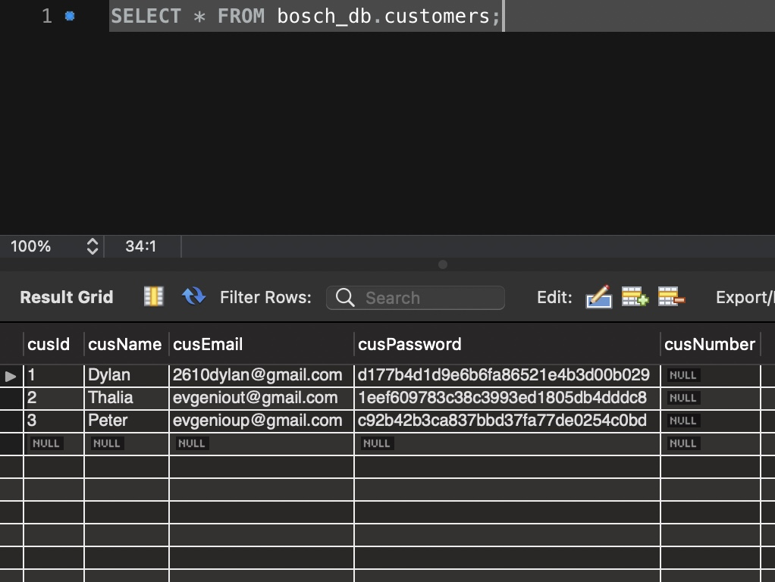

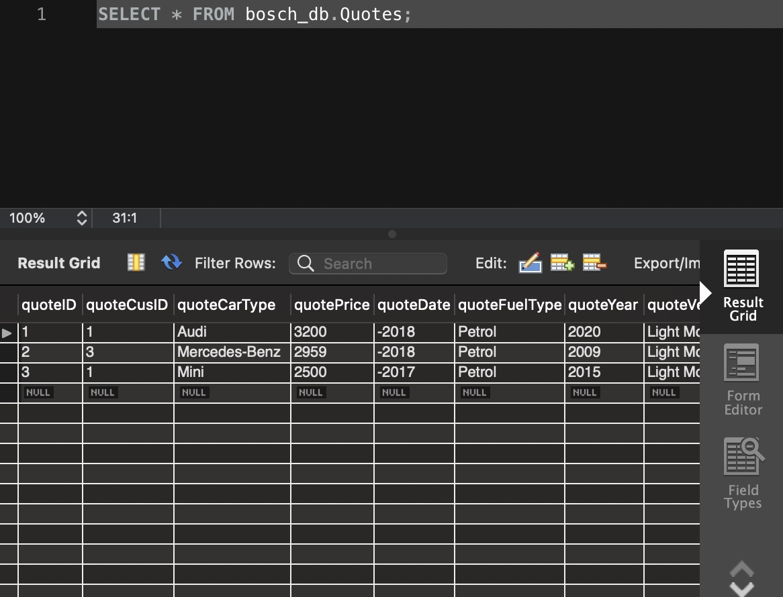

# Conclusion

In this document, I have identified how the data flow and system would run. The aid of these diagrams have helped me create the website needed by Bosch. Using these diagrams help identify what needs to be done and how to get there. After completing these diagrams I can see how vital they are for the development process. This helped me reach my goals within the website by identifying key areas that needed attention and work.

The use of these diagrams show us a simple way of looking at the system as a whole and what the system has to offer. This allows for non-programmers to understand what is going on and no background knowledge is needed to know what the system entails to do. We hope this system can improve the Bosch Business by providing more customers with the website I have created. The ultimate goal was to increase online traffic and I hope with this website we can achieve that goal. All the diagrams and guidelines within this document has allowed for firm structure to be introduced, this allowing for a suitable and beneficial website being made. The importance of documentation can be seen throughout the document and was much needed in the completion of this project.

# Sign-off

|  |  |  |  |
| --- | --- | --- | --- |
| Peter |  |  | Dylan |
| [Name], Project Client  Date: 13/06/2022 |  |  | [Name], Project Manager  Date: 13/06/2022 |